

**Chocolate Flower**

*Berlandiera lyrata*

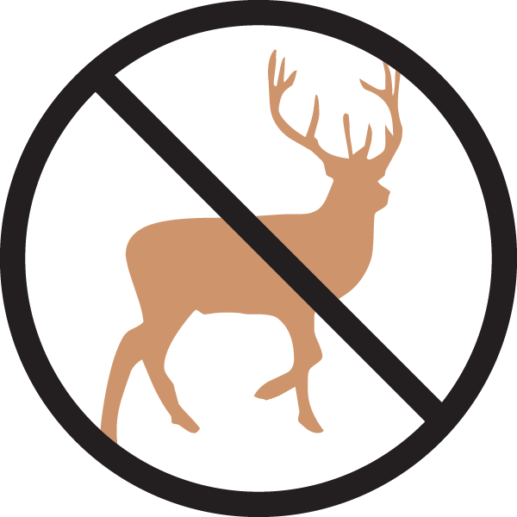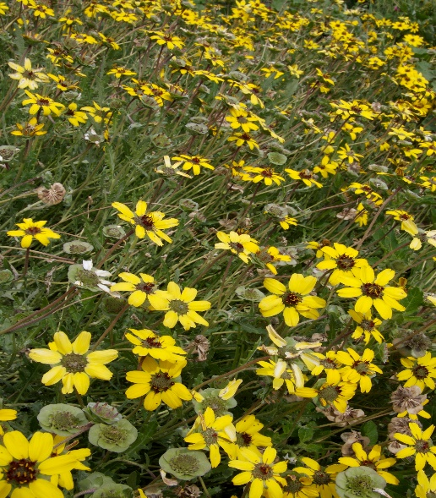

**Height: 10-14 in. Width: 12-20 in.**

Ever blooming native wildflower from the Southwest that produces a continuous succession of dark-eyed, yellow daisies over a compact rosette of foliage. The flowers exude a rich chocolate aroma in the morning hours. Best with minimal water once established. Can reseed.

**Culture:** Well-drained clay or sandy soil

**Hardiness:** USDA zones 4-9



WIND. HAIL. SNOW. SUN

**BRING IT ON**

www.plantselect.org

