

**Bellina pink cornflower**

*Psephellus simplicicaulis*

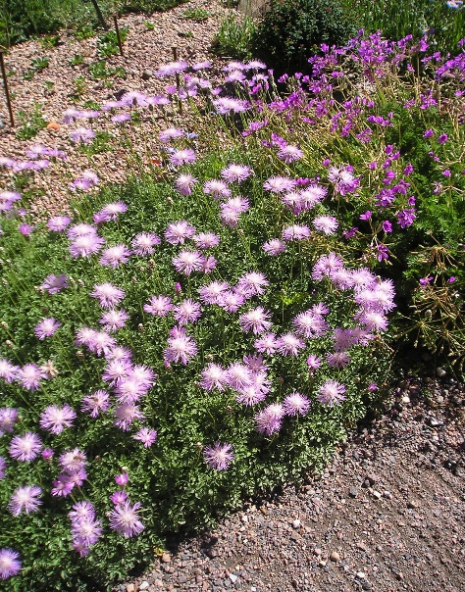

**Height: 4”, flower stems 8-10” Width: 12-18”**

A well-behaved invaluable small-scale perennial that produces bright pink pincushions from spring through summer. Few xeric perennials bloom as long or have such delightful habit and form. Use to edge walkways and flagstones or in perennial gardens.

**Culture:** Clay, loam or sandy

**Hardiness:** USDA zones 5-9



WIND. HAIL. SNOW. SUN

**BRING IT ON**

www.plantselect.org

