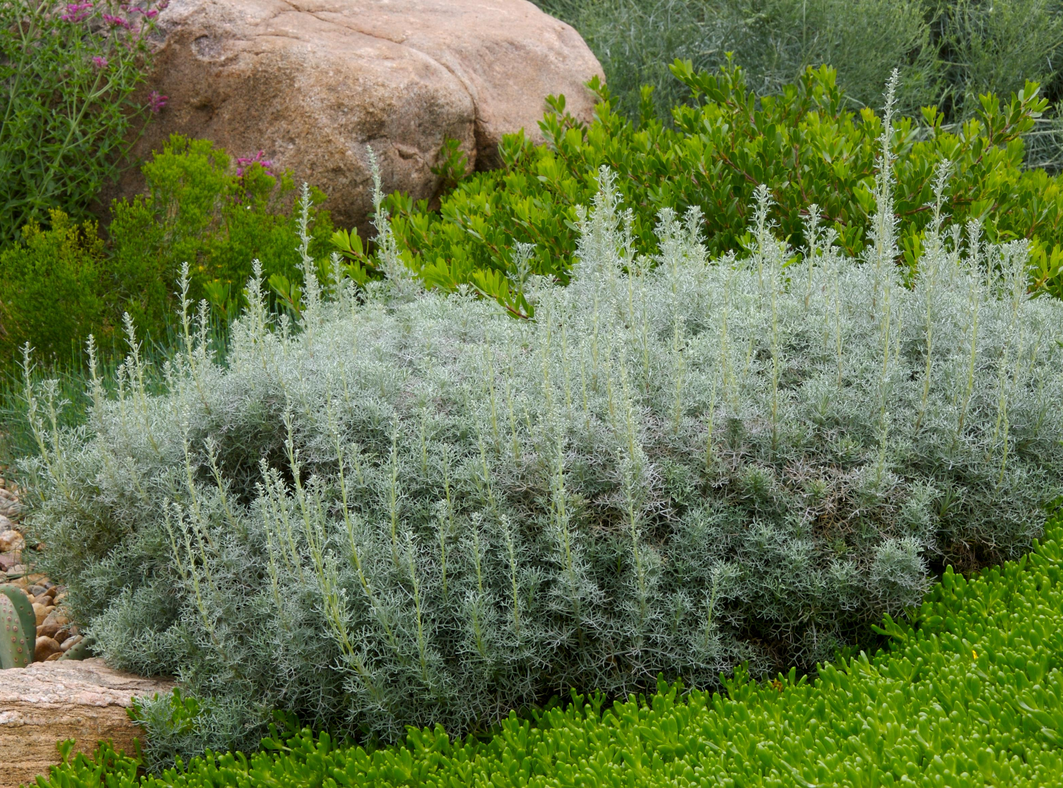

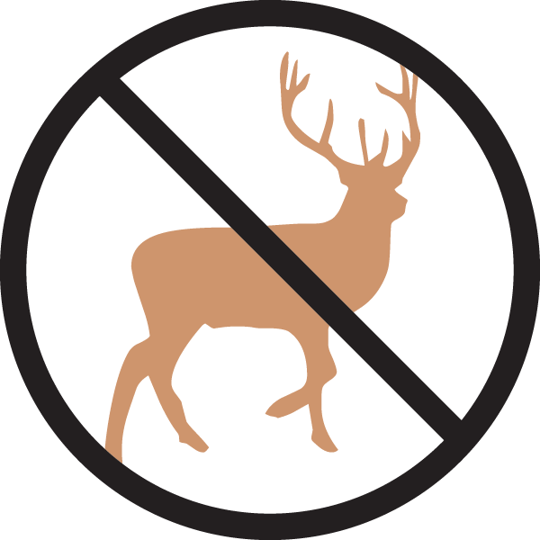

Height: 6-12”
Width: 16-30”
Blooms: Inconspicuous
Sun: Full sun to partial shade
Water: Moderate to dry
Hardiness: USDA zones 4b-8
Culture: Average, clay, or sandy soil
Introduced: 2004
Perennial
Vigorous, attractive groundcover with lacy, mounding foliage of silvery blue. Good winter presence. Clump forming and non-invasive.

Sea Foam Artemisia
Artemisia versicolor ‘Sea Foam’
www.plantselect.org

