
Sea Foam Artemisia
Artemisia versicolor ‘Sea Foam’






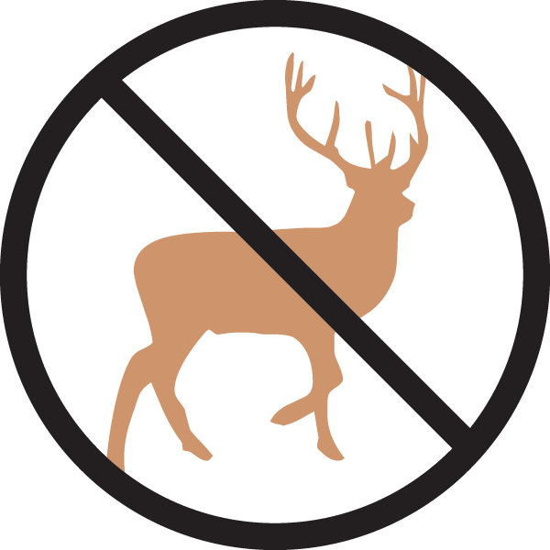
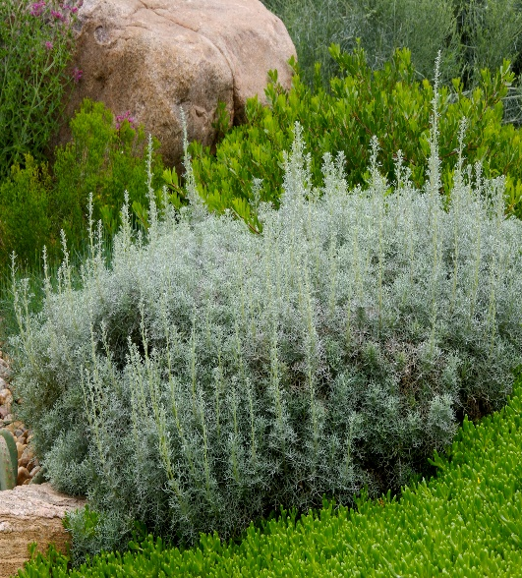

Height: 8-12 in. Width: 18-24 in.
Vigorous, attractive groundcover with lacy, mounding foliage of silvery blue. Good winter presence. Clump forming and non-invasive.
Culture: Clay, loam or sandy soil
Hardiness: USDA zones 4b-8



WIND. HAIL. SNOW. SUN
BRING IT ON

www.plantselect.org



