

**Sea Foam Artemisia**

*Artemisia versicolor*  ‘Sea Foam’

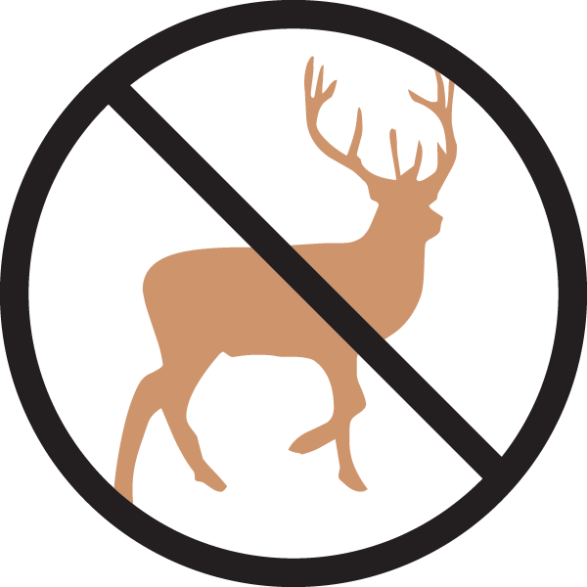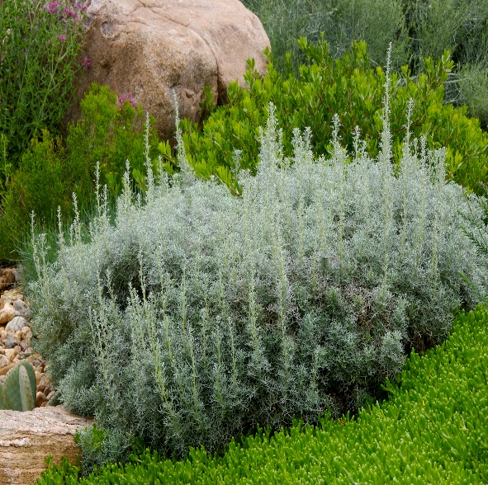

**Height: 8-12 in. Width: 18-24 in.**

Vigorous, attractive groundcover with lacy, mounding foliage of silvery blue. Good winter presence. Clump forming and non-invasive.

**Culture:** Clay, loam or sandy soil

**Hardiness:** USDA zones 4b-8



WIND. HAIL. SNOW. SUN

**BRING IT ON**

www.plantselect.org

