

**Leprechaun Southernwood**

*Artemisia abrotanum* ‘Leprechaun’

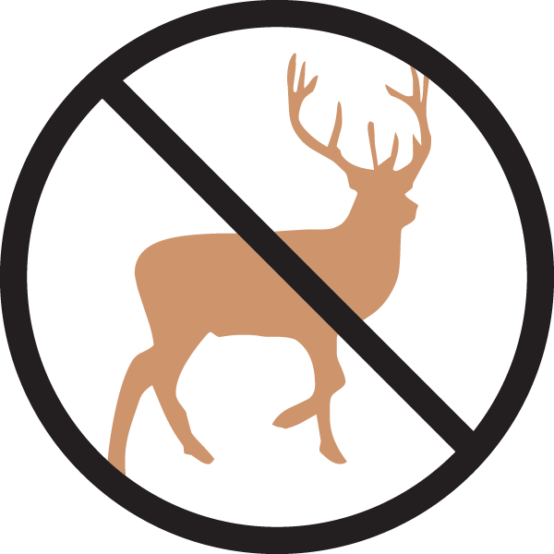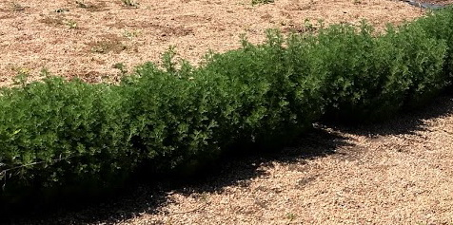

**Height: 24-36 in. Width: 24-30 in.**

A compact selection of the ancient garden herb that forms a dense, symmetrical mound of whorled silver-green foliage. Plant in mass to create a low garden hedge suggestive of boxwood. Cut back in January-early spring when fully dormant.

**Culture:** Loam or sandy soil

**Hardiness:** USDA zones 4-8



WIND. HAIL. SNOW. SUN

**BRING IT ON**

www.plantselect.org