
Panchito™ Manzanita
Arctostaphylos x coloradoensis





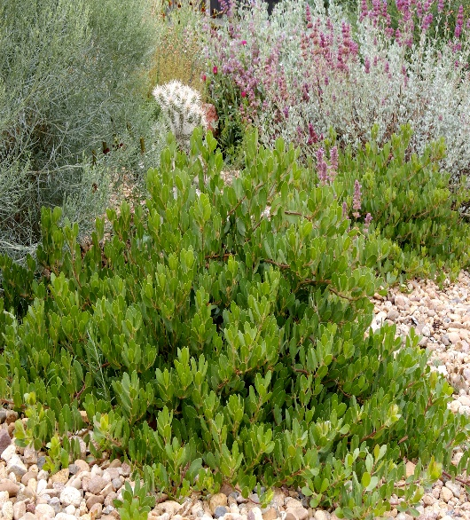




Height: 10-15 in. Width: 24-36 in.
Medium-sized selection of evergreen western manzanita with waxy, urn-shaped, pinkish-white flowers. Small red berries can be produced on established plants. Well drained sites only.
Culture: Well drained garden soil or sandy soil
Hardiness: USDA zones 4-8



WIND. HAIL. SNOW. SUN
BRING IT ON

www.plantselect.org



