

**Panchito™ Manzanita**

*Arctostaphylos x coloradoensis*

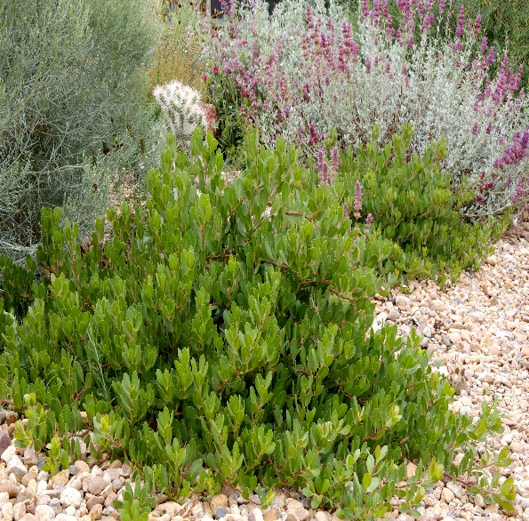

**Height: 10-15 in. Width: 24-36 in.**

Medium-sized selection of evergreen western manzanita with waxy, urn-shaped, pinkish-white flowers. Small red berries can be produced on established plants. Well drained sites only.

**Culture:** Well drained garden soil or sandy soil

**Hardiness:** USDA zones 4-8



WIND. HAIL. SNOW. SUN

**BRING IT ON**

www.plantselect.org

