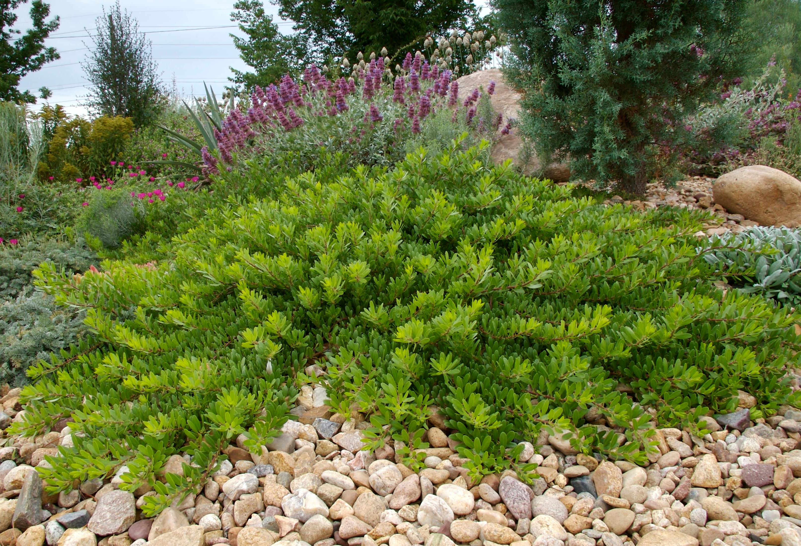



Height: 10-15”
Width: 36-60”
Blooms: February to April
Sun: Full sun to partial shade
Water: Xeric once established
Hardiness: USDA zones 4b-8 (up to 7,000’)
Culture: Average or sandy well drained soil
Introduced: 2005
Shrub
Low growing drought tolerant native broadleaf evergreen shrub select from the Uncompaghre Plateau by Betsy Baldwin. Dense prostrate form with smooth cinnamon-red to purplish exfoliating bark with bright glossy green leaves. Waxy pink tinged white flowers appear in early spring followed by a dry red berry in September-October. An excellent low ground-cover for well-drained soil.

Mock Bearberry Manzanita
Arctostaphylos x coloradoensis
www.plantselect.org

