
Mock Bearberry Manzanita
Arctostaphylos x coloradoensis







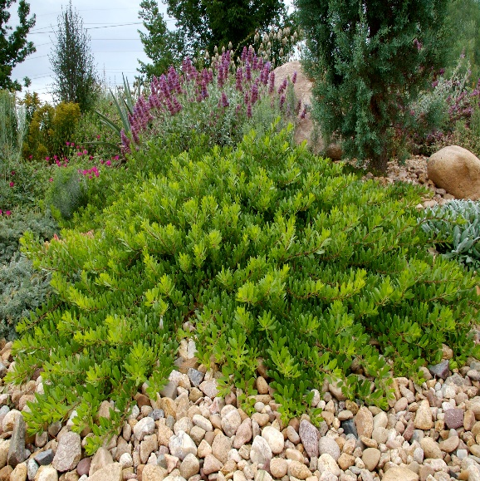


Height: 10-14 in. Width: 48-60 in.
Low groundcover selection of evergreen western manzanita with waxy, pinkish-white, urn shaped flowers. An excellent low ground-cover for well-drained soil.
Culture: Loam or sandy well-drained soil
Hardiness: USDA zones 4b-8



WIND. HAIL. SNOW. SUN
BRING IT ON

www.plantselect.org



