

**Mock Bearberry Manzanita**

*Arctostaphylos x coloradoensis*

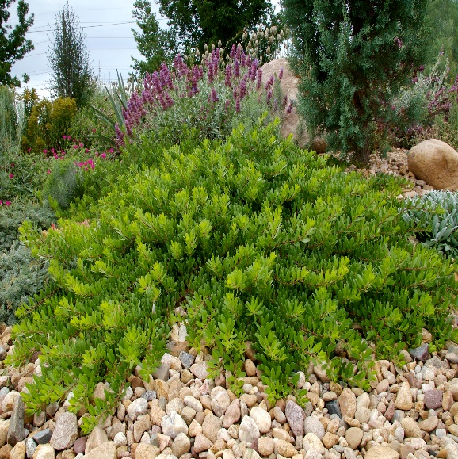

**Height: 10-14 in. Width: 48-60 in.**

Low groundcover selection of evergreen western manzanita with waxy, pinkish-white, urn shaped flowers. An excellent low ground-cover for well-drained soil.

**Culture:** Loam or sandy well-drained soil

**Hardiness:** USDA zones 4b-8



WIND. HAIL. SNOW. SUN

**BRING IT ON**

www.plantselect.org

