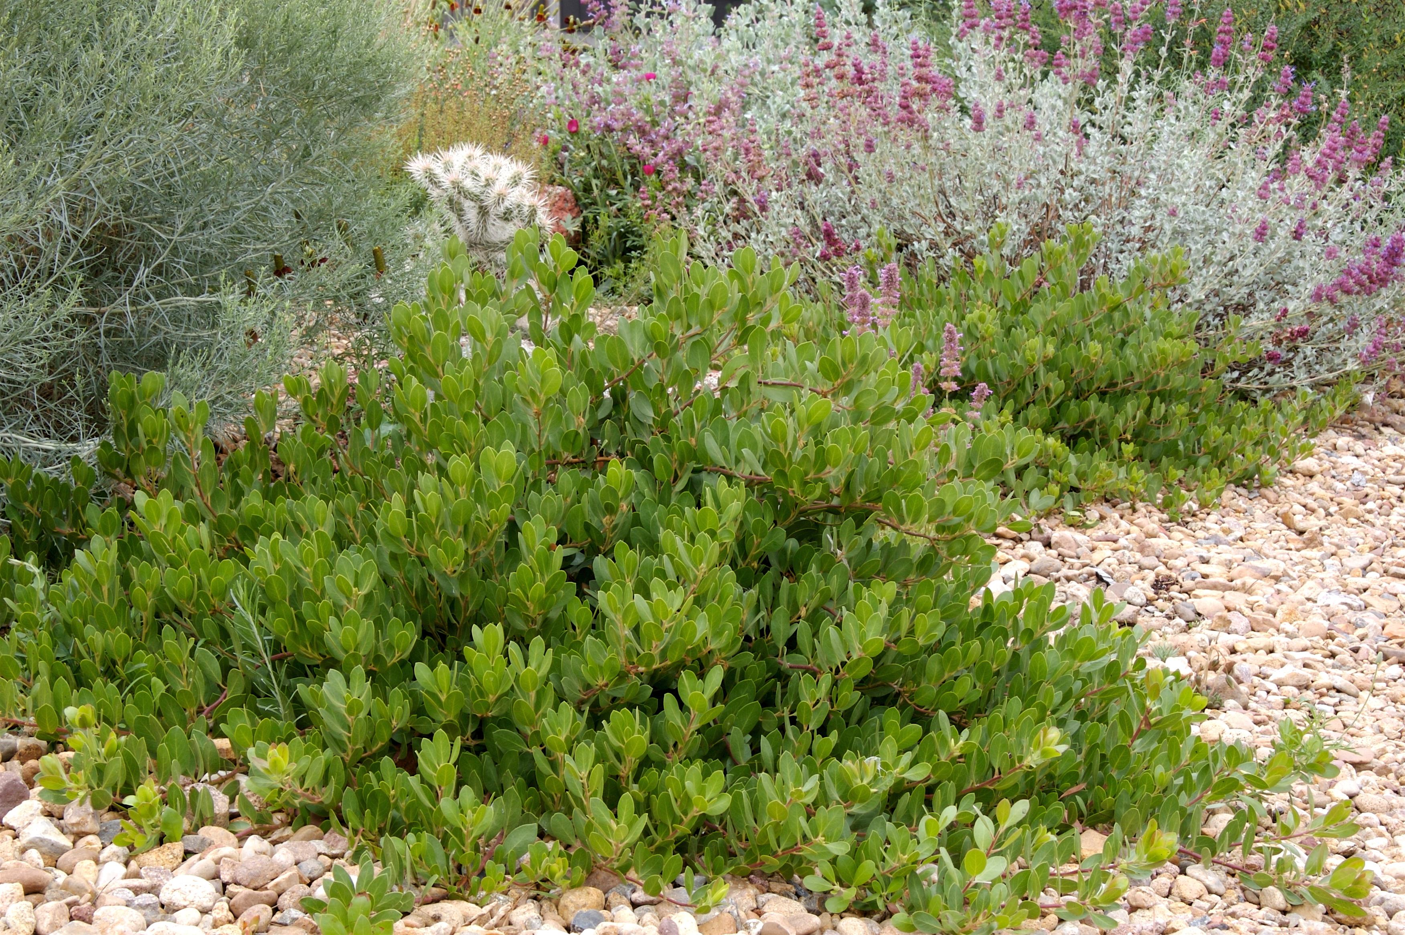



Height: 10-15”
Width: 24-36”
Blooms: February to April
Sun: Full sun to partial shade
Water: Moderate to xeric (once established)
Hardiness: USDA zones 4b-8 (up to 7,000’)
Culture: Well drained garden soil or sandy soil
Introduced: 2006
Shrub
Outstanding selection of a native, broadleaf evergreen from the Uncompahgre plateau in Western Colorado. Tiny, waxy white urn-shaped flowers are very appealing. Small red berries can be produced on established plants. First selected and cultivated by Dermod Downs and Betsy Baldwin.

Panchito™ Manzanita
Arctostaphylos x coloradoensis
www.plantselect.org

