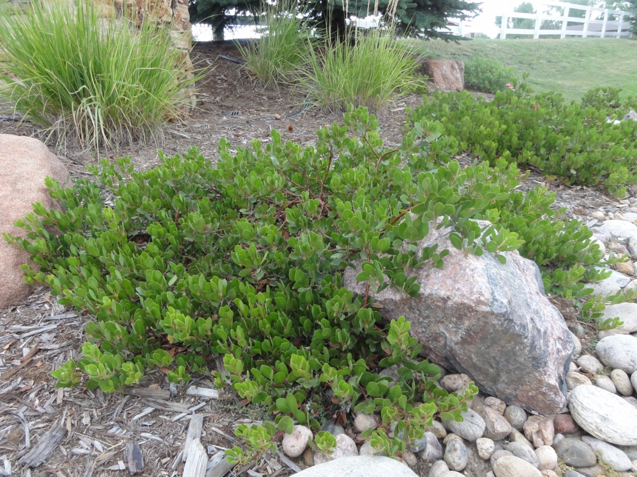

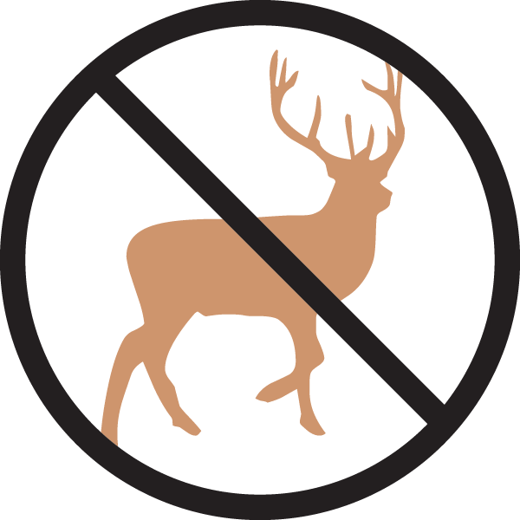

Height: 18-36”
Width: 5-8’
Blooms: April
Sun: Full sun to partial shade
Water: Moderate to xeric, once established
Hardiness: USDA zones 5-8
Culture: Well-drained loam or sandy soil
Introduced: 2013
Evergreen Groundcover
Oval leaves emerge with a reddish tint changing to bold dark green, persisting through the winter. White flowers tinged with pink appear late in spring followed by red berries in early fall. Striking, smooth cinnamon-red to purplish exfoliating bark appears as the plant matures.

Chieftain Manzanita
Arctostaphylos x coloradensis ‘Chieftain’
www.plantselect.org

