
Chieftain Manzanita
Arctostaphylos x coloradensis ‘Chieftain’

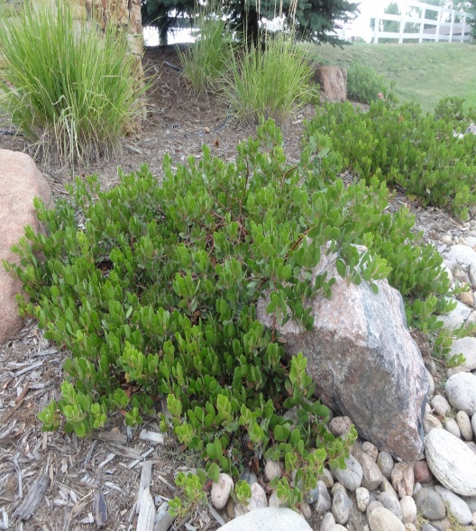

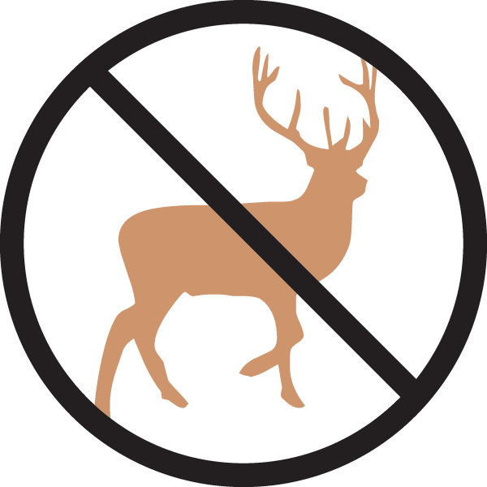






Height: 18-36 in. Width: 5-8 ft.
Oval leaves emerge with a reddish tint changing to bold dark green, persisting through the winter. White flowers tinged with pink appear late in spring followed by red berries in early fall. Striking, smooth cinnamon-red to purplish exfoliating bark appears as the plant matures.
Culture: Well-drained loam or sandy soil
Hardiness: USDA zones 5-8



WIND. HAIL. SNOW. SUN
BRING IT ON

www.plantselect.org



