

**Chieftain Manzanita**

*Arctostaphylos x coloradensis ‘*Chieftain’

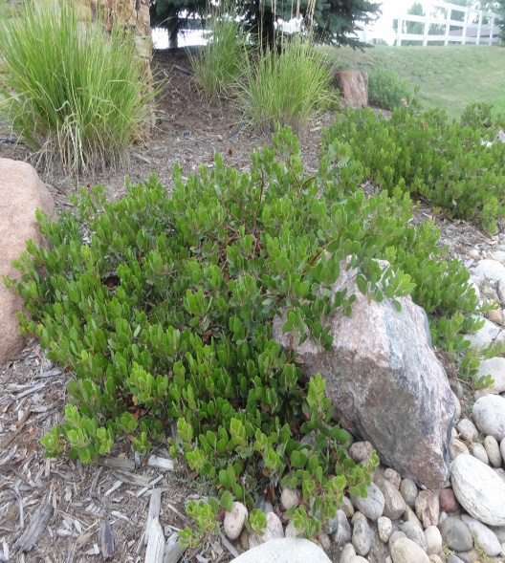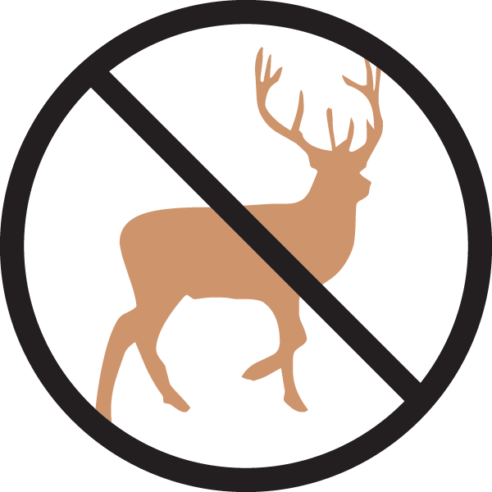

**Height: 18-36 in. Width: 5-8 ft.**

Oval leaves emerge with a reddish tint changing to bold dark green, persisting through the winter. White flowers tinged with pink appear late in spring followed by red berries in early fall. Striking, smooth cinnamon-red to purplish exfoliating bark appears as the plant matures.

**Culture:** Well-drained loam or sandy soil

**Hardiness:** USDA zones 5-8



WIND. HAIL. SNOW. SUN

**BRING IT ON**

www.plantselect.org

