


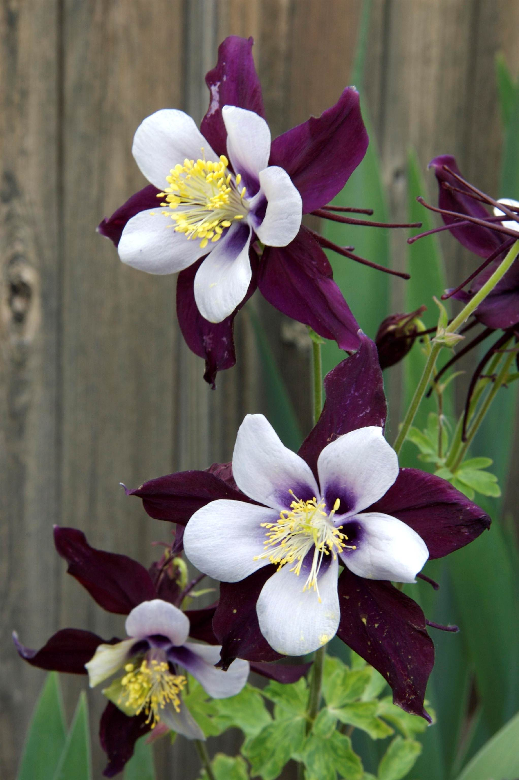
Height: 14-24”
Width: 15-18”
Blooms: Late spring to early summer
Sun: Partial sun
Water: Moderate
Hardiness: USDA zones 3-9
Culture: Average, well-drained soil
Introduced: 2001
Perennial
A hybrid derived from the Colorado state flower, the petals and spurs are an incredibly rich, shining violet-blue. The name honors the memory of students and teachers of Columbine High School who shall never be forgotten. Proceeds will benefit organizations that promote diversity and tolerance in schools.

Remembrance® Columbine
Aquilegia ‘Swan Violet & White’
www.plantselect.org

