
Remembrance® Columbine
Aquilegia ‘Swan Violet & White’




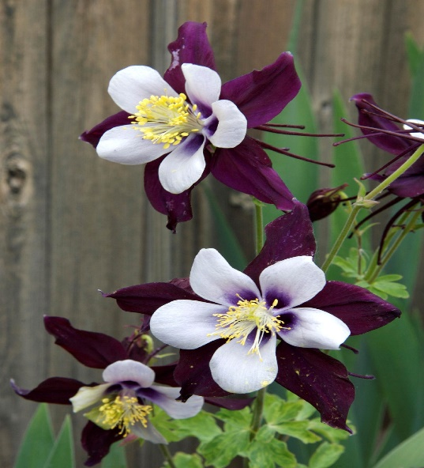

Height: 18-24 in. Width: 16-18 in.
A hybrid derived from the Colorado state flower, the petals and spurs are an incredibly rich, shining violet-blue. The name honors the memory of students and teachers of Columbine High School who shall never be forgotten. Blooms late spring to early summer.
Culture: Loam
Hardiness: USDA zones 3-9



WIND. HAIL. SNOW. SUN
BRING IT ON

www.plantselect.org



