

**Remembrance® Columbine**

*Aquilegia* ‘Swan Violet & White’

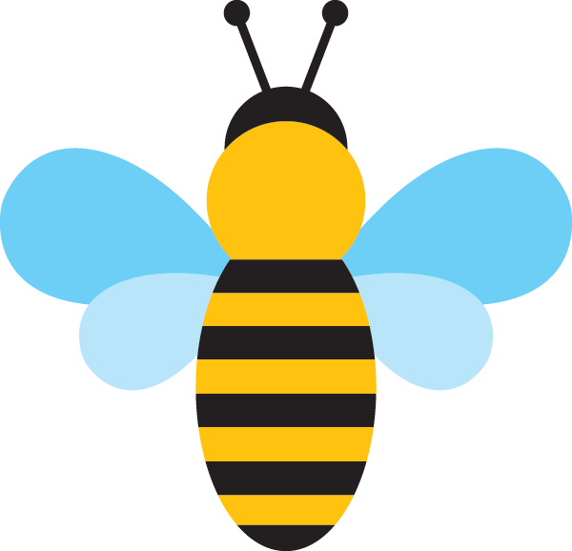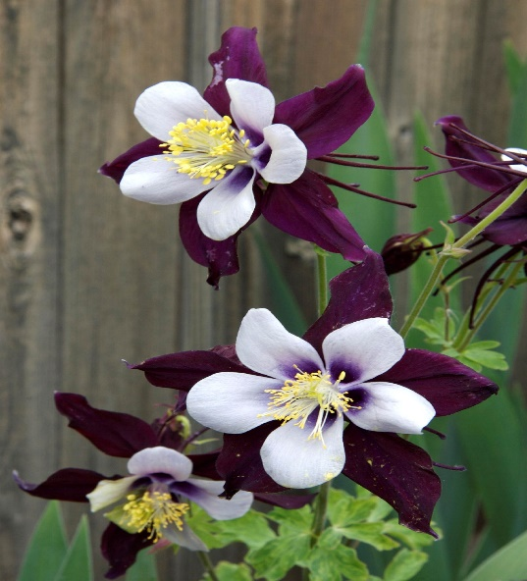

**Height: 18-24 in. Width: 16-18 in.**

A hybrid derived from the Colorado state flower, the petals and spurs are an incredibly rich, shining violet-blue. The name honors the memory of students and teachers of Columbine High School who shall never be forgotten. Blooms late spring to early summer.

**Culture:** Loam

**Hardiness:** USDA zones 3-9



WIND. HAIL. SNOW. SUN

**BRING IT ON**

www.plantselect.org

