


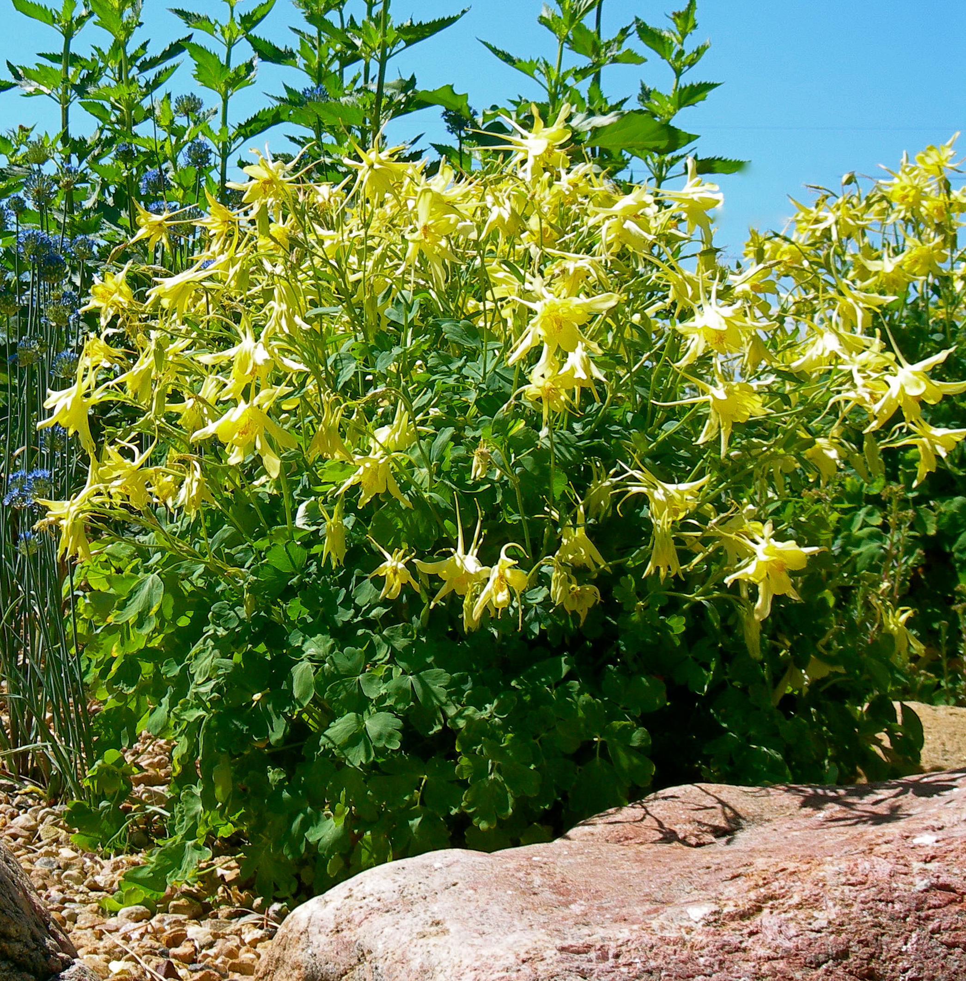
Height: 30”
Width: 15”
Blooms: Late spring; heavy re-bloom later
Sun: Full sun to deep shade
Water: Moderate
Hardiness: USDA zones 3-8
Culture: Sandy soil or clay loam
Introduced: 2001
Perennial
A particularly showy race of the golden columbine of the southern Rockies. The huge, yellow flowers can be over three inches across and the spurs are even longer. The plants often bloom from May to autumn frost and self sow generously.

Denver Gold® Columbine
Aquilegia chrysantha
www.plantselect.org

