
Denver Gold® Columbine
Aquilegia chrysantha

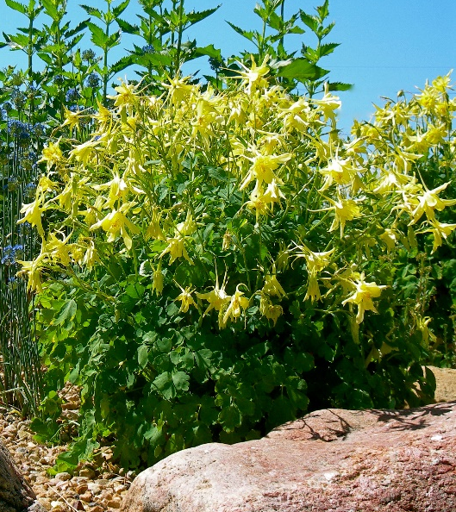





Height: 30 in. Width: 15 in.
A particularly showy race of the golden columbine of the southern Rockies. The huge, yellow flowers can be over three inches across and the spurs are even longer. The plants often bloom from May to autumn frost and self-sow generously.
Culture: Sandy soil or clay loam
Hardiness: USDA zones 3-8



WIND. HAIL. SNOW. SUN
BRING IT ON

www.plantselect.org



