

**Denver Gold® Columbine**

*Aquilegia chrysantha*

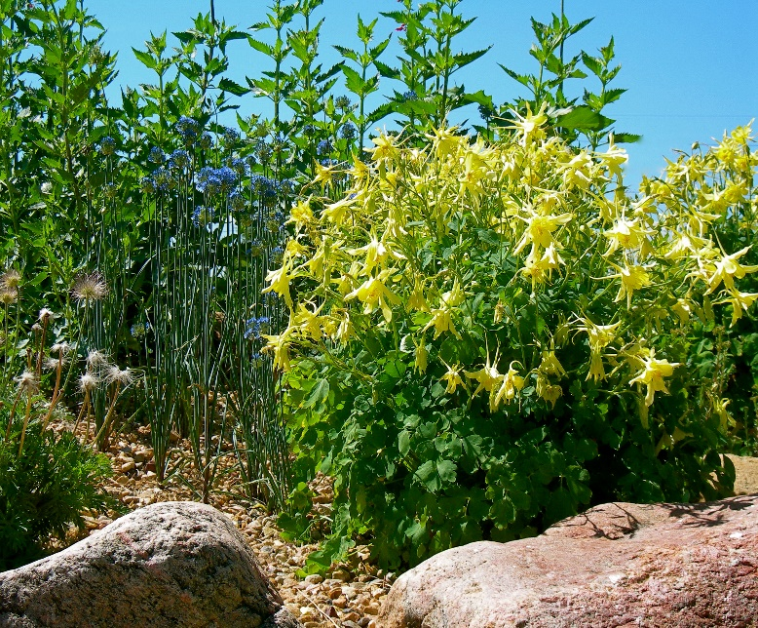

**Height: 30 in. Width: 15 in.**

A particularly showy race of the golden columbine of the southern Rockies. The huge, yellow flowers can be over three inches across and the spurs are even longer. The plants often bloom from May to autumn frost and self-sow generously.

**Culture:** Sandy soil or clay loam

**Hardiness:** USDA zones 3-8



WIND. HAIL. SNOW. SUN

**BRING IT ON**

www.plantselect.org

