

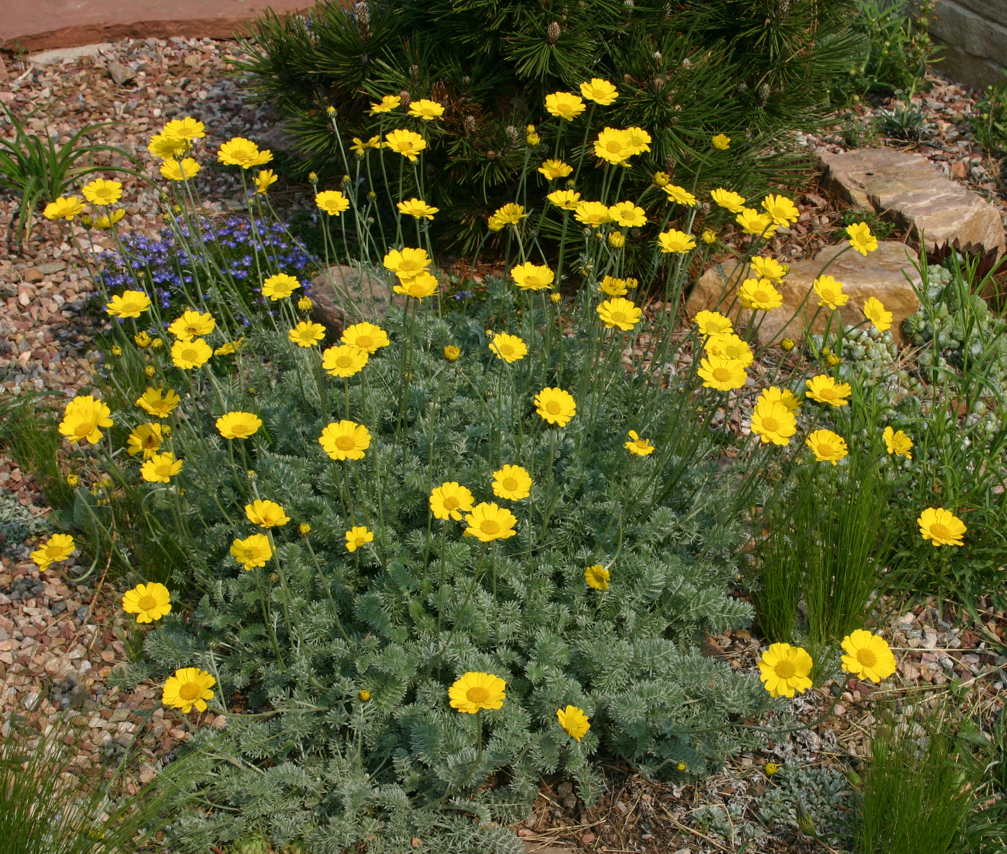
Height: 4-10”
Width: 15-24”
Blooms: May to June
Sun: Full sun to partial shade
Water: Moderate to xeric
Hardiness: USDA zones 4-10 (up to 7,000’)
Culture: Sandy or clay soil
Introduced: 2012
Perennial
Lacy mat of silvery foliage beautiful through much of the year, but in May and June the chrome-yellow daisies glow for weeks on end. This tough, mat-forming perennial from West Asia will become a centerpiece of your xeriscape or dry border. Also grows in loamy soils if not over fertilized.

Filigree Daisy
Anthemis marschalliana
www.plantselect.org

