
Filigree Daisy
Anthemis marschalliana


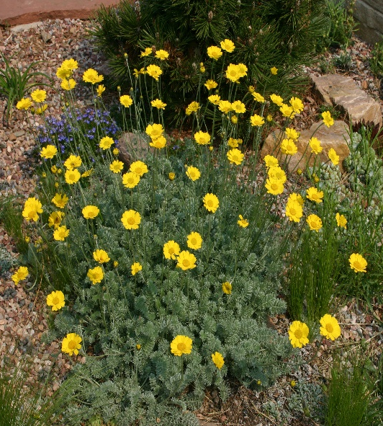




Height: 4-10 in. Width: 15-24 in.
Lacy mat of silvery foliage beautiful through much of the year, but in May and June the chrome-yellow daisies glow for weeks on end. This tough, mat-forming perennial from West Asia will become a centerpiece of your xeriscape or dry border. Also grows in loamy soils if not over fertilized.
Culture: Sandy or clay soil
Hardiness: USDA zones 4-10



WIND. HAIL. SNOW. SUN
BRING IT ON

www.plantselect.org



