

**Filigree Daisy**

*Anthemis marschalliana*

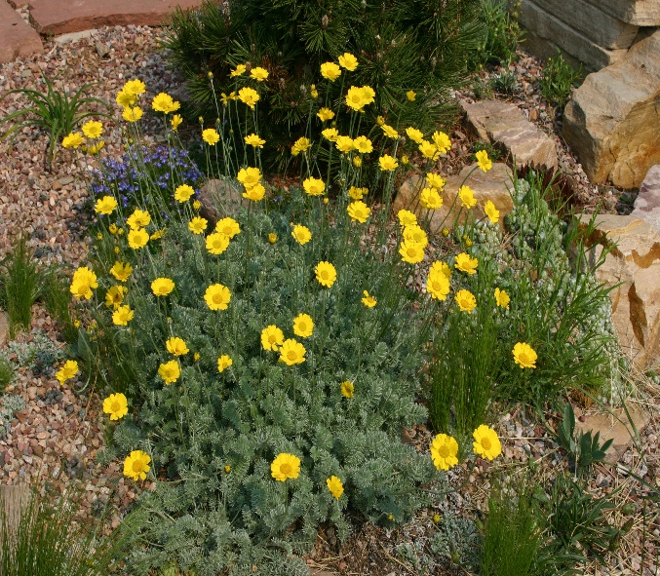

**Height: 4-10 in. Width: 15-24 in.**

Lacy mat of silvery foliage beautiful through much of the year, but in May and June the chrome-yellow daisies glow for weeks on end. This tough, mat-forming perennial from West Asia will become a centerpiece of your xeriscape or dry border. Also grows in loamy soils if not over fertilized.

**Culture:** Sandy or clay soil

**Hardiness:** USDA zones 4-10



WIND. HAIL. SNOW. SUN

**BRING IT ON**

www.plantselect.org

