
Windwalker® big bluestem
Andropogon gerardii ‘ PWIN01S’

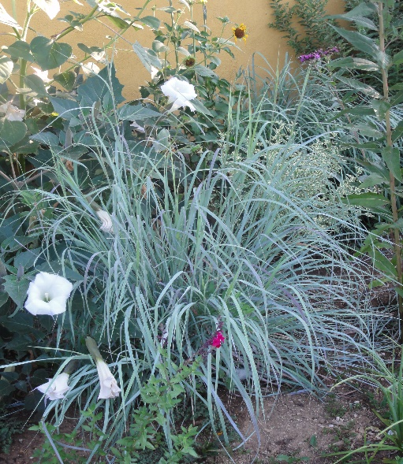





Height: 60-72” Width: 2 ft.
A regal, upright ornamental grass selected for its incredible powdery blue foliage that turns plum/purple in September when its burgundy plumes wave high in the air. Columnar form makes it ideal for both residential and commercial applications.
Culture: Average soil
Hardiness: USDA zones 5-8



WIND. HAIL. SNOW. SUN
BRING IT ON

www.plantselect.org



