

**Windwalker® big bluestem**

*Andropogon gerardii ‘* PWIN01S’

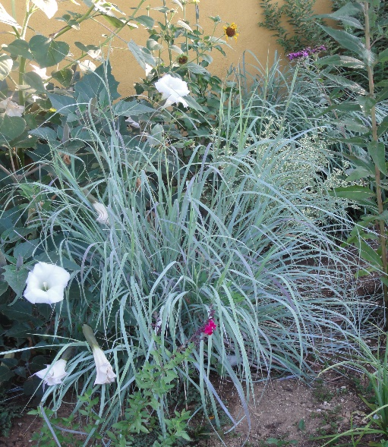

**Height: 60-72” Width: 2 ft.**

A regal, upright ornamental grass selected for its incredible powdery blue foliage that turns plum/purple in September when its burgundy plumes wave high in the air. Columnar form makes it ideal for both residential and commercial applications.

**Culture:** Average soil

**Hardiness:** USDA zones 5-8



WIND. HAIL. SNOW. SUN

**BRING IT ON**

www.plantselect.org

