



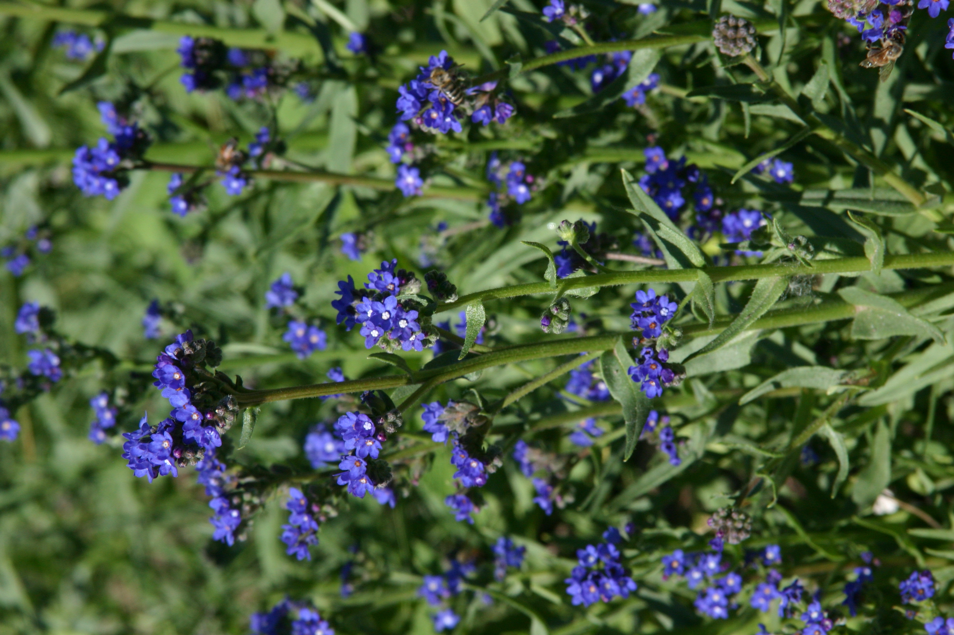
Height: 8-15”
Width: 4-8”
Blooms: May to October
Sun: Full sun to partial shade
Water: Moderate
Hardiness: USDA zones 5-10 (up to 5,000’)
Culture: Average soil
Introduced: 2012
Perennial
Trim evergreen rosettes produce a bounty of dazzling cobalt-blue flowers with fetching white eyes throughout the garden season. This will naturalize with moderate self-sowing in many border situations, filling blank corners of the border with luminous twilight blue. Also grows in amended sandy or clay soils.

Cape-Forget-Me-Not
Summer-Forget-Me-Not
Anchusa capensis
www.plantselect.org

