
Cape-forget-me-not
Anchusa capensis

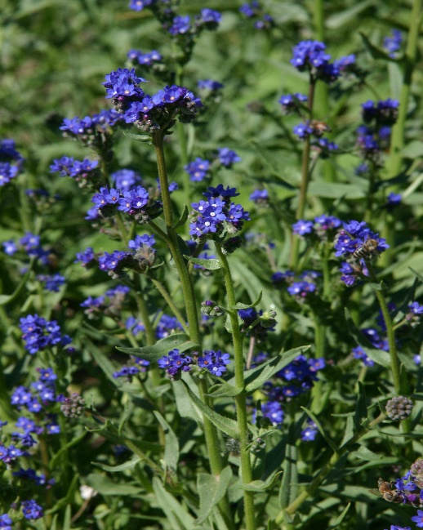
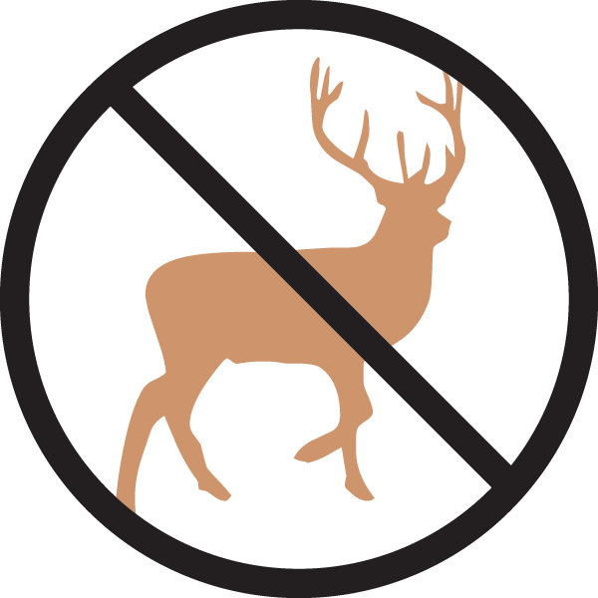





Height: 12-16 in. Width: 4-8 in.
Trim evergreen rosettes produce a bounty of dazzling cobalt-blue flowers with fetching white eyes throughout the garden season. This will naturalize with moderate self-sowing in many border situations, filling blank corners of the border with luminous twilight blue.
Culture: Clay, loam, or sandy loam
Hardiness: USDA zones 5-10



WIND. HAIL. SNOW. SUN
BRING IT ON

www.plantselect.org



