

**Cape-forget-me-not**

*Anchusa capensis*

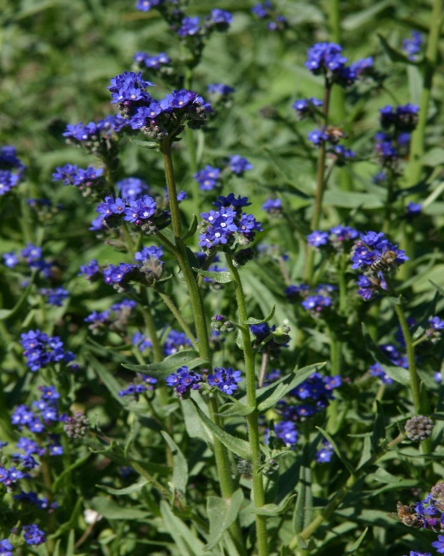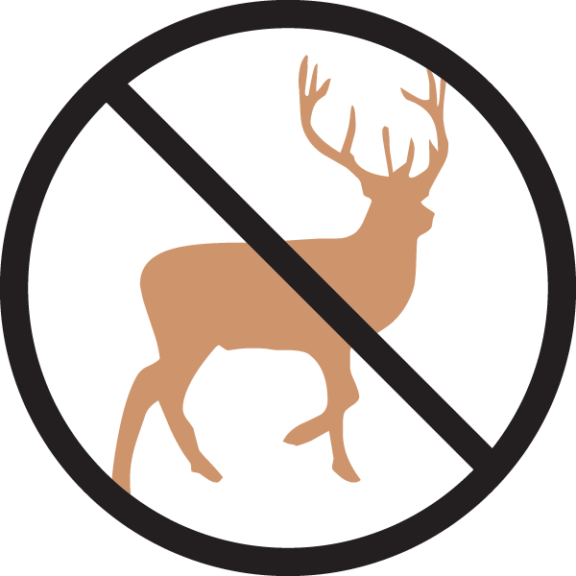

**Height: 12-16 in. Width: 4-8 in.**

Trim evergreen rosettes produce a bounty of dazzling cobalt-blue flowers with fetching white eyes throughout the garden season. This will naturalize with moderate self-sowing in many border situations, filling blank corners of the border with luminous twilight blue.

**Culture:** Clay, loam, or sandy loam

**Hardiness:** USDA zones 5-10



WIND. HAIL. SNOW. SUN

**BRING IT ON**

www.plantselect.org

