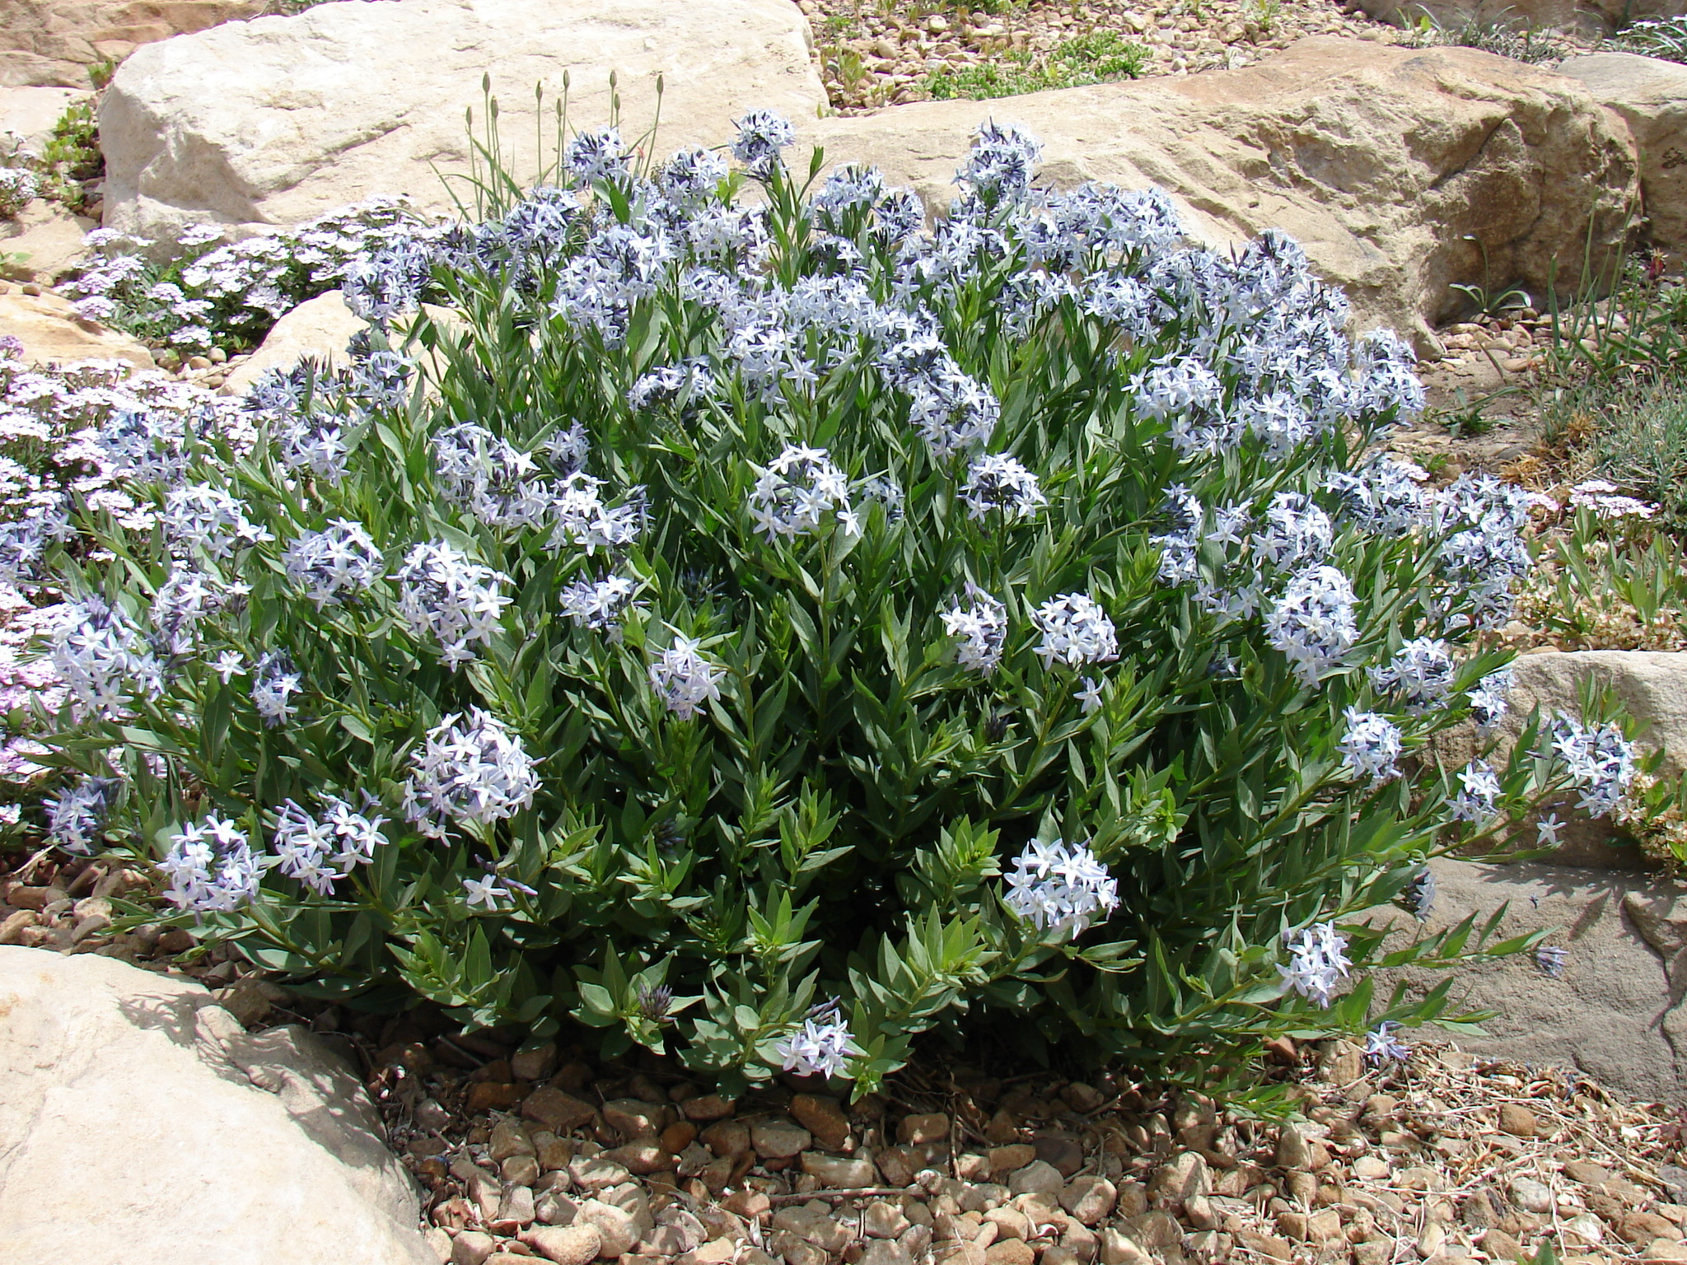




Height: 10-14”
Width: 12-15”
Blooms: April to June
Sun: Full sun
Water: Moderate to xeric
Hardiness: USDA zones 4-9 (up to 8,000’)
Culture: Clay, sandy loam, or loam soils
Introduced: 2011
Perennial
This widely adaptable western native thrives in ordinary gardens or un-watered xeriscape. Sapphire blue stars from April to early summer. Autumn foliage is a beautiful, clear yellow.

Colorado Desert Blue Star
Amonsia jonesii
www.plantselect.org

