

**Amorpha nana**

*Dwarf Leadplant*

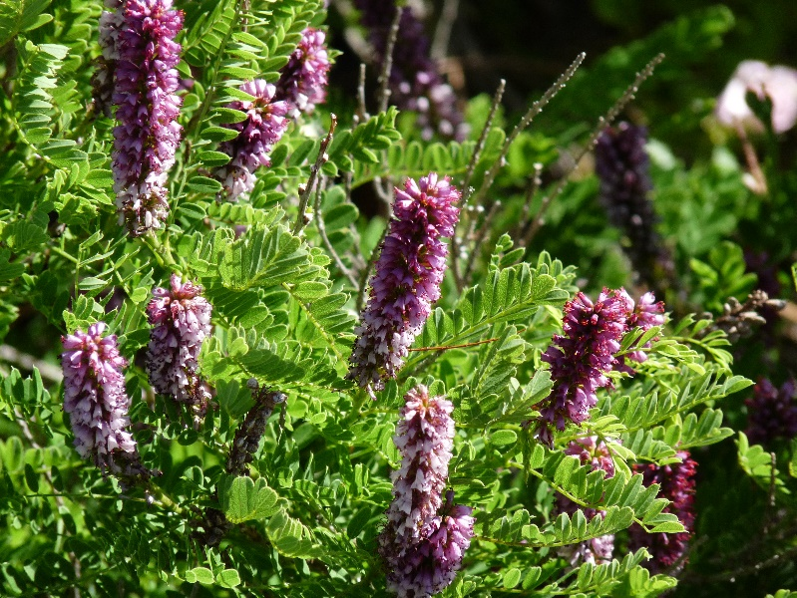

**Height: 2-3 ft. Width: 2-3 ft.**

A native shrub that blooms spikes of honey-scented purple flowers in June. Dwarf Leadplant can take nitrogen from the air and transform it into a nitrate fertilizer with the help of a symbiotic soil-dwelling microbe called Rhizobium. As a result, this shrub can thrive in impoverished soils, in full sun, and with very little water.

**Culture:** Loam or sandy soil

**Hardiness:** USDA zones 4-8



WIND. HAIL. SNOW. SUN

**BRING IT ON**

www.plantselect.org