
Colorado desert blue star
Amonsia jonesii






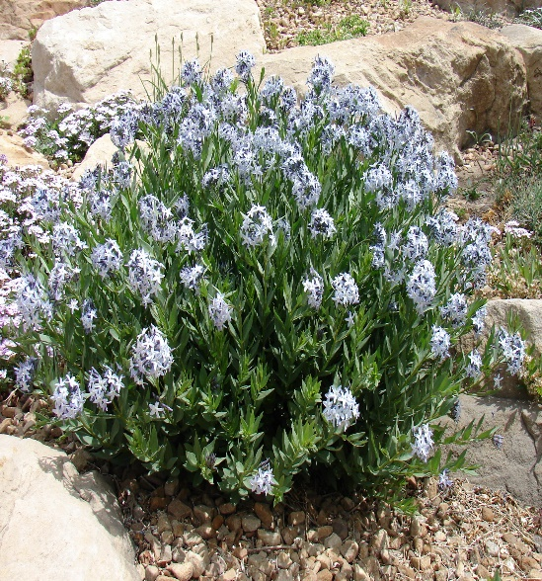


Height: 10-14 in. Width: 12-16 in.
This widely adaptable western native thrives in ordinary gardens or un-watered xeriscape. Sapphire blue stars from April to early summer. Autumn foliage is a beautiful, clear yellow.
Culture: Clay, sandy loam, or loam soils
Hardiness: USDA zones 4-9 (up to 8,000 ft.)



WIND. HAIL. SNOW. SUN
BRING IT ON

www.plantselect.org



