

**Colorado desert blue star**

*Amonsia jonesii*

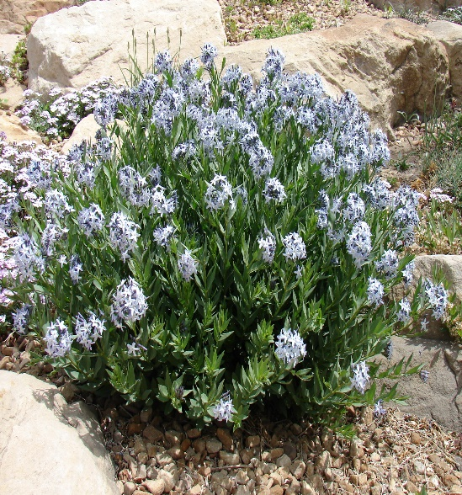

**Height: 10-14 in. Width: 12-16 in.**

This widely adaptable western native thrives in ordinary gardens or un-watered xeriscape. Sapphire blue stars from April to early summer. Autumn foliage is a beautiful, clear yellow.

**Culture:** Clay, sandy loam, or loam soils

**Hardiness:** USDA zones 4-9 (up to 8,000 ft.)



WIND. HAIL. SNOW. SUN

**BRING IT ON**

www.plantselect.org

