
Sunset® Hyssop
Agastache rupestris

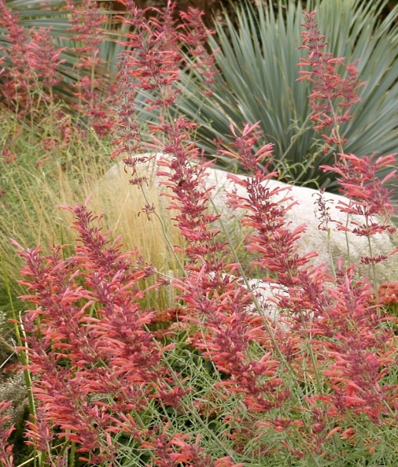








Height: 20-24 in. Width: 12-16 in.
Bold brushes of sunset orange flowers from August to frost. Native to high mountains of the Southwest, the whole plant exudes a rich, root beer aroma. An exotic contribution to water-smart gardens or perennial borders.
Culture: Loam or sandy soil
Hardiness: USDA zones 4b-10



WIND. HAIL. SNOW. SUN
BRING IT ON

www.plantselect.org



