

**Sunset® Hyssop**

*Agastache rupestris*

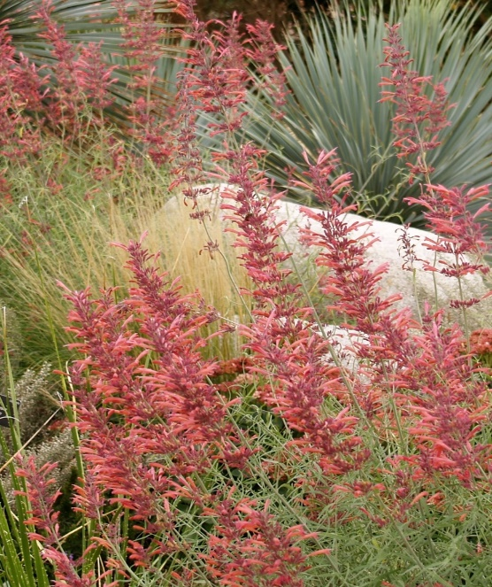

**Height: 20-24 in. Width: 12-16 in.**

Bold brushes of sunset orange flowers from August to frost. Native to high mountains of the Southwest, the whole plant exudes a rich, root beer aroma. An exotic contribution to water-smart gardens or perennial borders.

**Culture:** Loam or sandy soil

**Hardiness:** USDA zones 4b-10



WIND. HAIL. SNOW. SUN

**BRING IT ON**

www.plantselect.org

