



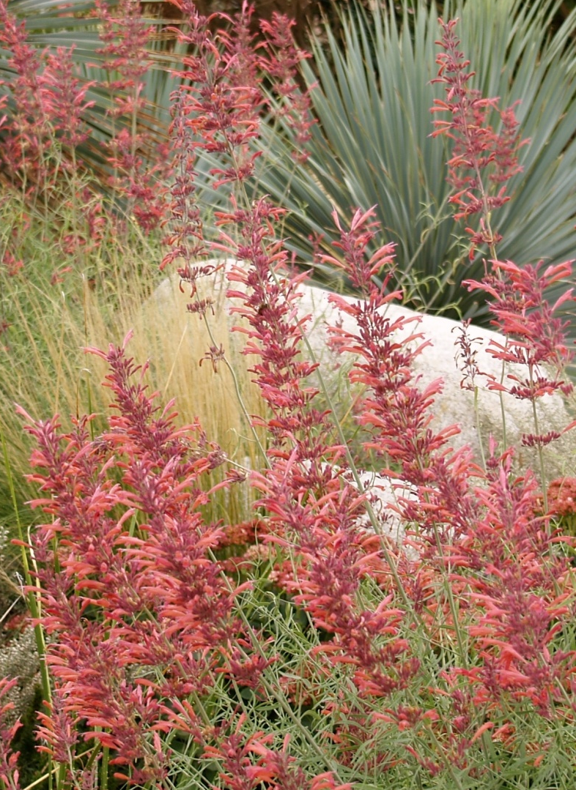
Height: 20-24”
Width: 8-15”
Blooms: August to frost
Sun: Full sun to partial shade
Water: Moderate watering to dry
Hardiness: USDA zones 4b-10
Culture: Average to poor soil
Introduced: 1997
Perennial
Bold brushes of sunset orange flowers from August to frost. Native to high mountains of the Southwest, the whole plant exudes a rich, root beer aroma. An exotic contribution to water-smart gardens or perennial borders.

Sunset® Hyssop
Agastache rupestris
www.plantselect.org

