
Coronado® Red Hyssop
Agastache ‘Pstessene’






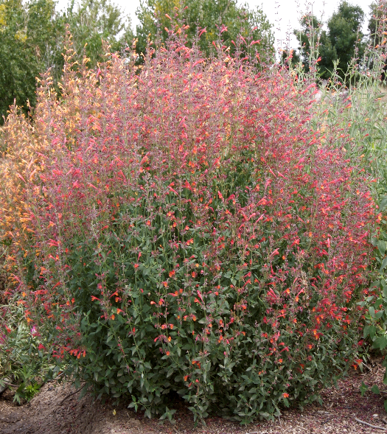


Height: 16-18 in. Width: 12-16 in.
Brilliant crimson and maroon spires are produced over a long summer season. This distinct selection from Welby Gardens brings exciting new color shade to an outstanding group of aromatic native mints.
Culture: Loam or sandy soil
Hardiness: USDA zones 5-9



WIND. HAIL. SNOW. SUN
BRING IT ON

www.plantselect.org



