

**Coronado® Red Hyssop**

*Agastache ‘Pstessene’*

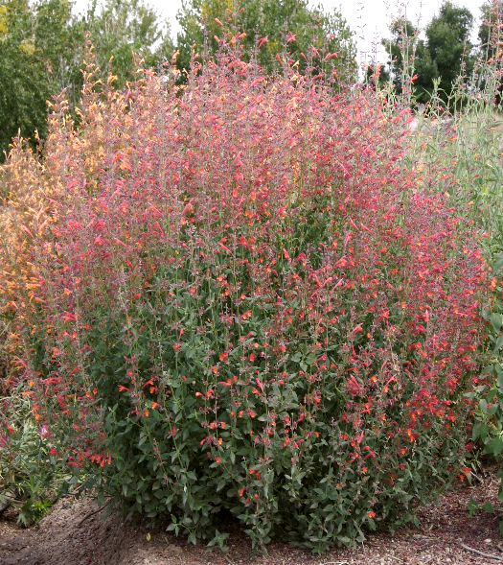

**Height: 16-18 in. Width: 12-16 in.**

Brilliant crimson and maroon spires are produced over a long summer season. This distinct selection from Welby Gardens brings exciting new color shade to an outstanding group of aromatic native mints.

**Culture:** Loam or sandy soil

**Hardiness:** USDA zones 5-9



WIND. HAIL. SNOW. SUN

**BRING IT ON**

www.plantselect.org

