

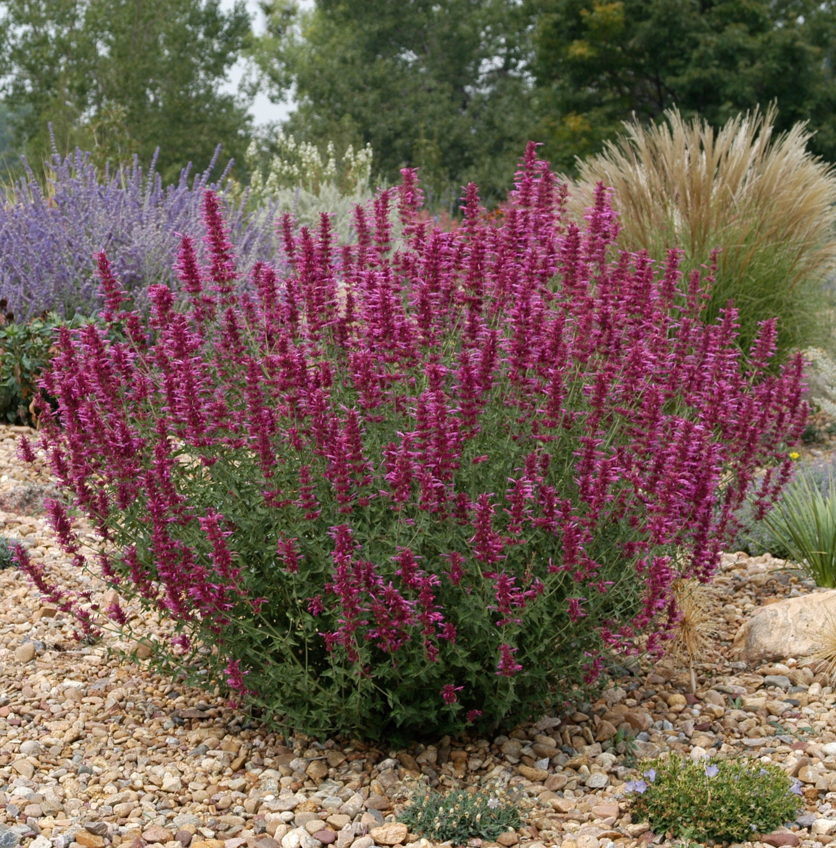
Height: 15”
Width: 12-15”
Blooms: Late summer to fall
Sun: Full sun to partial shade
Water: Moderate to dry
Hardiness: USDA zones 5-9
Culture: Average soil
Introduced: 2002
Perennial
A compact, large-flowered selection, that has proven to be a superior clone, blooming earlier and longer, with much showier lavender-rose flowers than the species.

Sonoran Sunset® Hyssop
Agastache cana ‘Sinning’ ^{PP13,673}
www.plantselect.org

