

**Sonoran Sunset® Hyssop**

*Agastache cana* ‘Sinning’ PP13,673

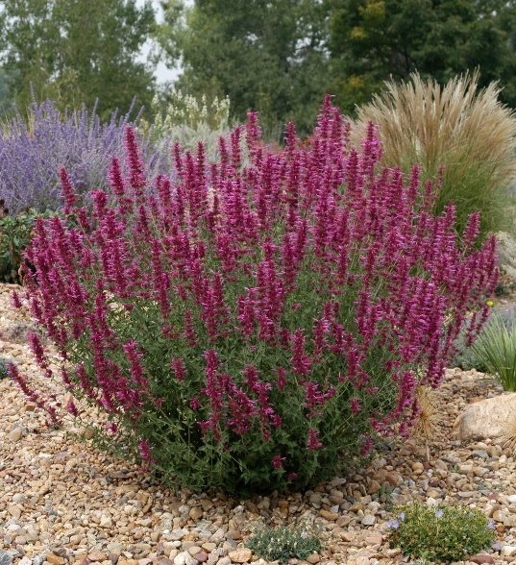

**Height: 18 in. Width: 12-16 in.**

A compact, large-flowered selection that has proven to be a superior clone, blooming earlier and longer, with much showier lavender-rose flowers than the species.

**Culture:** Loam or sandy soil

**Hardiness:** USDA zones 5-9



WIND. HAIL. SNOW. SUN

**BRING IT ON**



www.plantselect.org

