

**Coronado® Hyssop**

*Agastache aurantiaca* ‘PO12S’

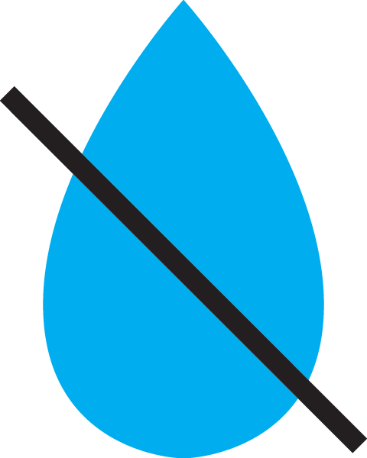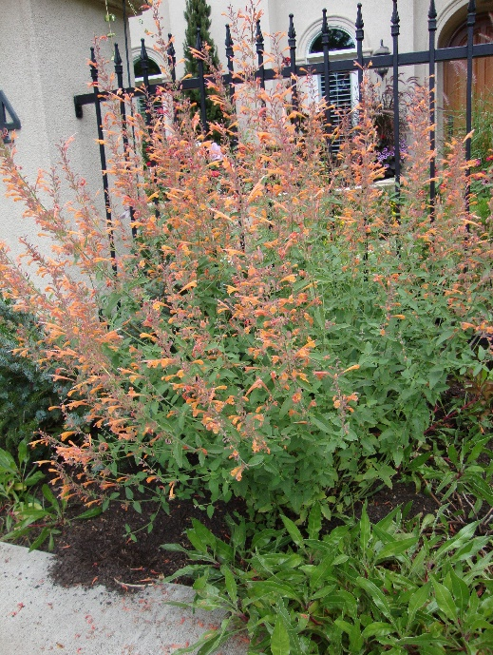

**Height: 18 in. Width: 16 in.**

Yellow, stained with orange, helmets of fiery color from midsummer to autumn frost. This silvery-leaved southwestern wildflower is intensely aromatic. Sunny, well drained sites.

**Culture:** Loam or sandy soil

**Hardiness:** USDA zones 5-9



WIND. HAIL. SNOW. SUN

**BRING IT ON**



www.plantselect.org

