



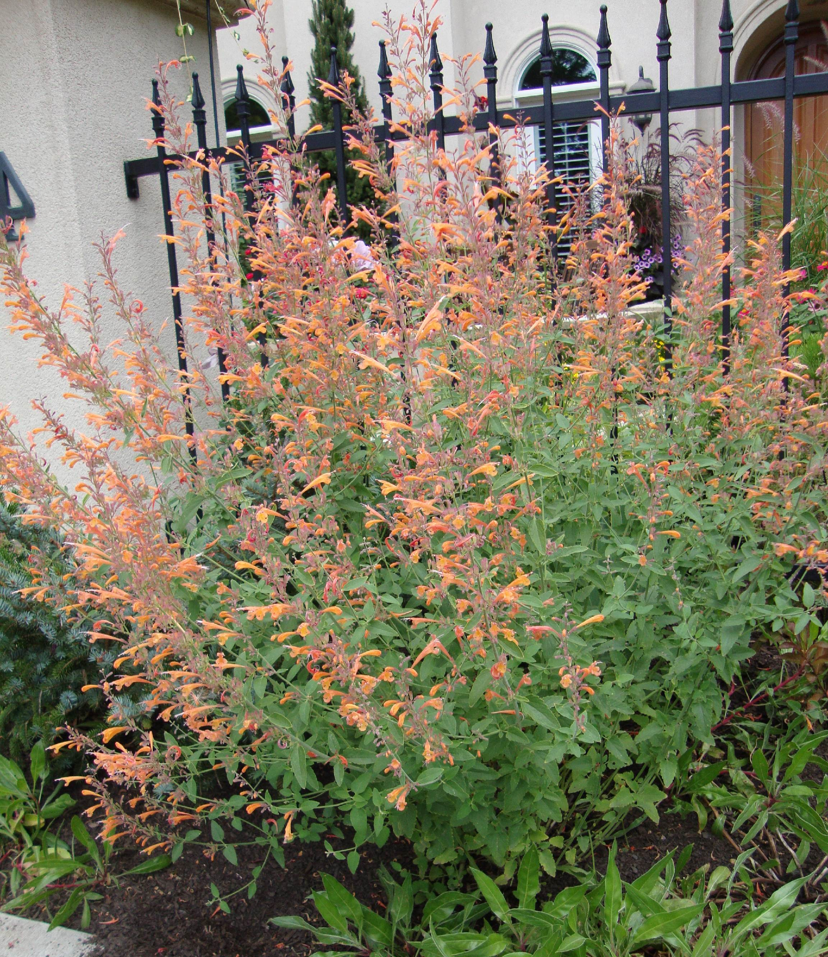
Height: 15”
Width: 12”
Blooms: Summer to fall
Sun: Full sun to partial shade
Water: Moderate to dry
Hardiness: USDA zones 4b-8
Culture: Average soil
Introduced: 2001
Perennial
Yellow, stained with orange, helmets of fiery color from midsummer to autumn frost. This silvery-leaved southwestern wildflower is intensely aromatic. Sunny, well drained sites.

Coronado® Hyssop
Agastache aurantiaca
www.plantselect.org

