
Hot Wings® Tatarian Maple
Acer tataricum ‘GarAnn’ ^{PP15,023}

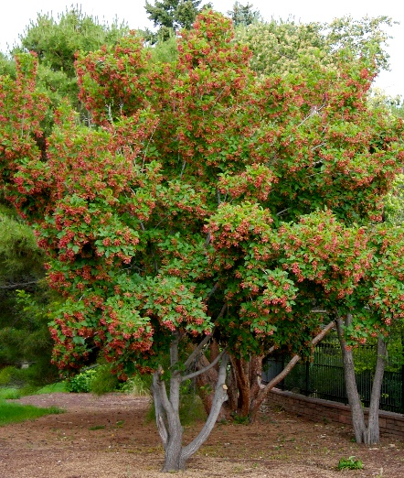





Height: 15-18 ft. Width: 15-18 ft.
Brilliant red samaras look like flaming flowers all summer long. Attractive sturdy tree with showy fall color. Ideal for home landscapes.
Culture: Average soil
Hardiness: USDA zones 4-10



WIND. HAIL. SNOW. SUN
BRING IT ON

www.plantselect.org



