

**Hot Wings® Tatarian Maple**

*Acer tataricum* ‘GarAnn’ PP15,023

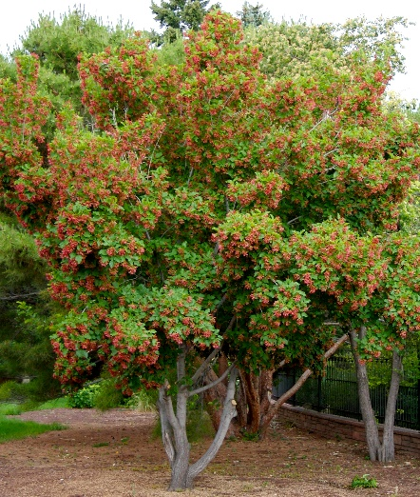

**Height: 15-18 ft. Width: 15-18 ft.**

Brilliant red samaras look like flaming flowers all summer long. Attractive sturdy tree with showy fall color. Ideal for home landscapes.

**Culture:** Average soil

**Hardiness:** USDA zones 4-10



WIND. HAIL. SNOW. SUN

**BRING IT ON**

www.plantselect.org

