

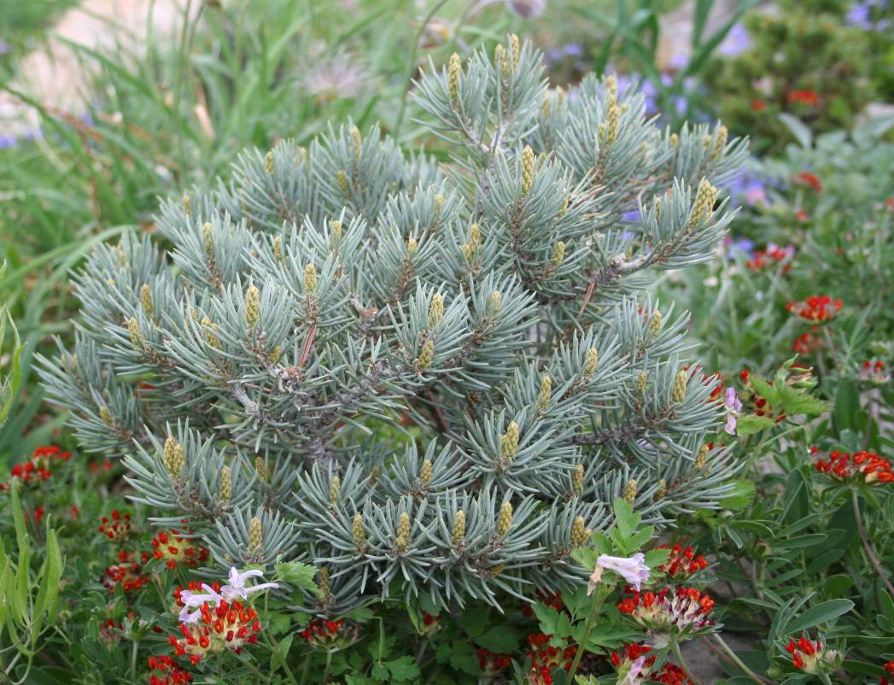
Height: 24” (1-3” per year)
Width: 24”
Blooms: NA
Sun: Full sun to part shade
Water: Moderate to dry
Hardiness: USDA zones 4-7
Culture: Well-drained, sandy
Recommended: 2016
Dwarf Conifer
What could be a better choice for beauty and interest year-round in a water-wise garden than a dwarf blue pinyon pine? Slow-growing, adaptable and durable, Blue Jazz is the most ornamental of the dwarf pinyon pines now available. This globe-forming little pine is the perfect addition to any garden that needs a permanent small evergreen presence.
Blue Jazz pinion pine
Pinus monophylla ‘Blue Jazz’
www.plantselect.org

