





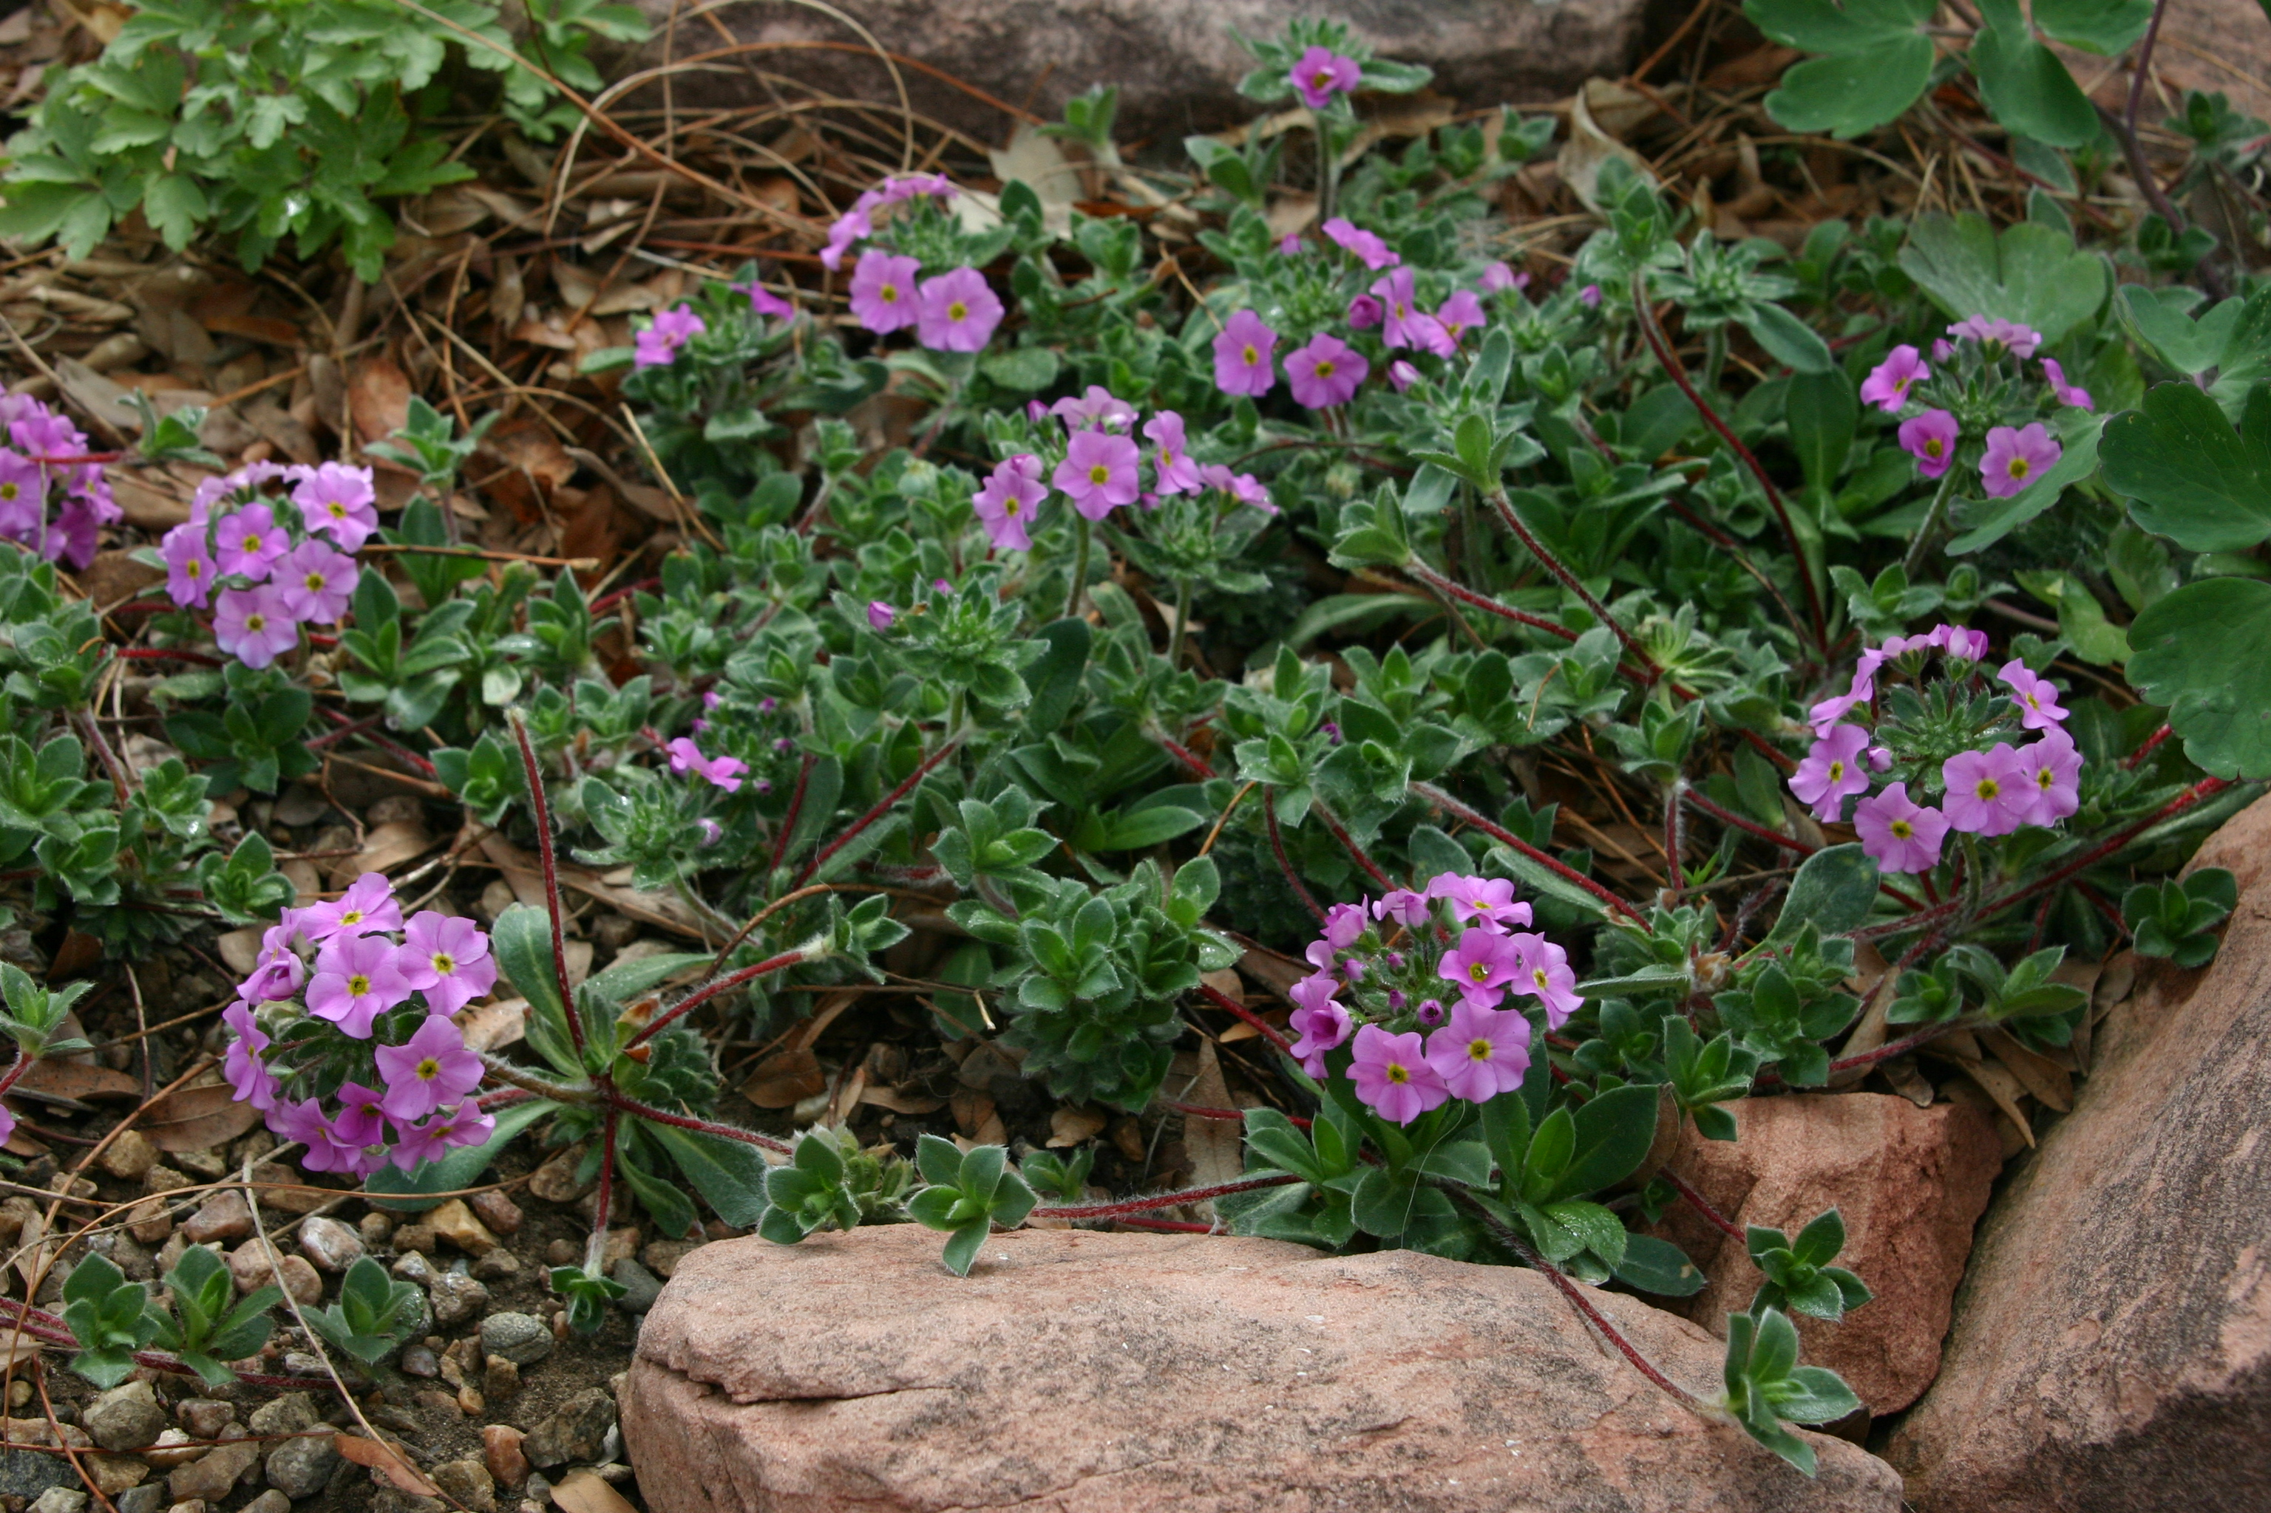
Height: 2-4 in.
Width: 8-12 in.
Hardiness: USDA zones 3-8
Culture: Loam or sandy soils
Charming yet tough little plant from high in the Himalayas. Furry gray-green rosettes proliferate with strawberry like red runners to form intricate, silky semi-evergreen patches. Cluster of fragrant pink flowers with yellow eyes rise on short stems in early summer, a focal point in rock gardens or permanent containers. Avoid hot, humid situations; thrives in sun or partial shade.
Silky Rock Jasmine
Androsace sarmentosa ‘Chumbyi’
www.plantselect.org

