
Red Feathers
Echium russicum (compact form)




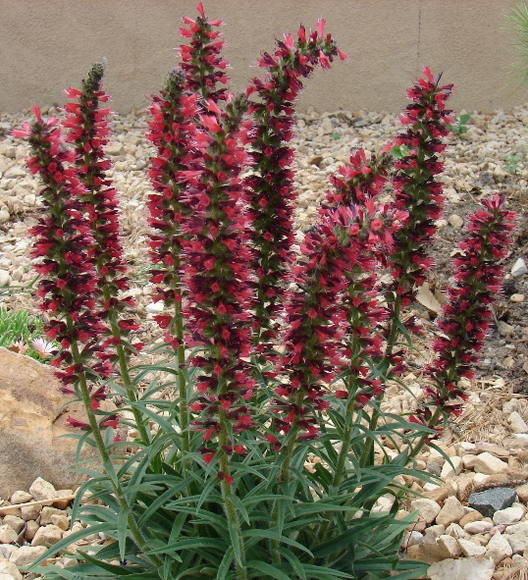





Height: 10-16 in. Width: 6-8 in.
This astonishing perennial recently introduced from the Caucasus consists of a basal tuft of dark green, linear leaves which produce spikes of feathery, russet-red flowers in spring, re-blooming again in summer and fall if deadheaded.
Culture: Clay, loam, or sandy soils
Hardiness: USDA zones 3-9



WIND. HAIL. SNOW. SUN
BRING IT ON

www.plantselect.org



