

**Red Feathers**

*Echium russicum* (compact form)

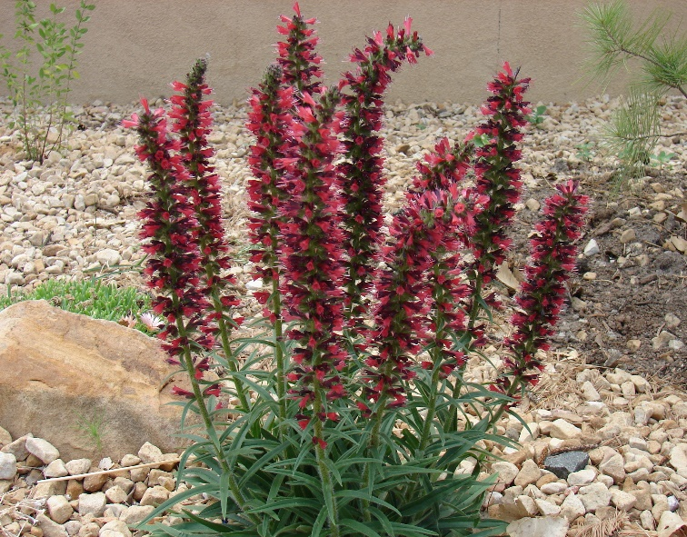

**Height: 10-16 in. Width: 6-8 in.**

This astonishing perennial recently introduced from the Caucasus consists of a basal tuft of dark green, linear leaves which produce spikes of feathery, russet-red flowers in spring, re-blooming again in summer and fall if deadheaded.

**Culture:** Clay, loam, or sandy soils

**Hardiness:** USDA zones 3-9



WIND. HAIL. SNOW. SUN

**BRING IT ON**

www.plantselect.org

