

**Turquoise Tails Blue Sedum**

*Sedum sediforme*

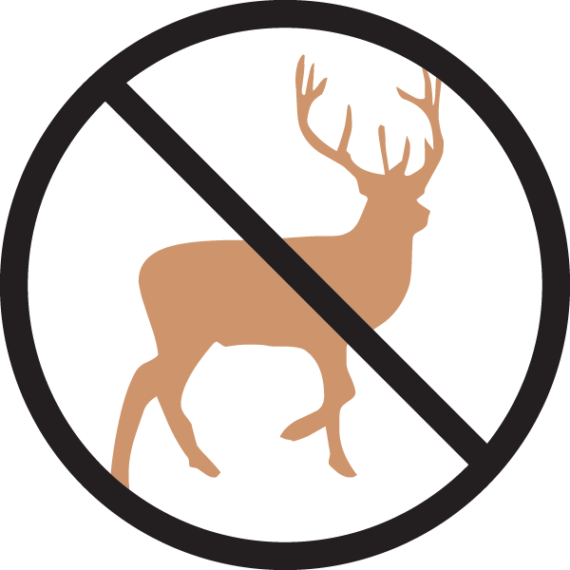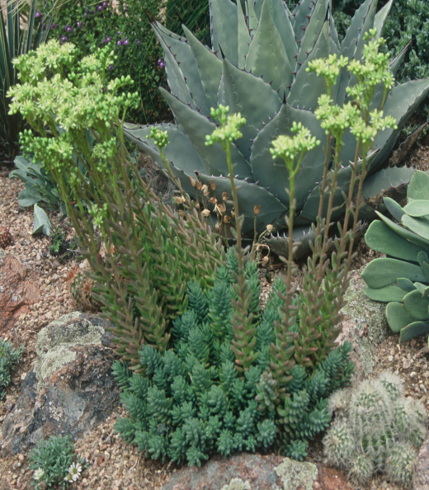

**Height: 4-6 in. Width: 8-12 in.**

Creamy-yellow flowers rise above succulent blue mounds in mid-summer, creating sculptural accent for xeric gardens. Attracts bees, is virtually deer-resistant, suitable for green roofs, and evergreen, too!

**Culture:** Clay, loam or sandy soil

**Hardiness:** USDA zones 5-10



WIND. HAIL. SNOW. SUN

**BRING IT ON**

www.plantselect.org

