

**Giant sacaton**

*Sporobolus wrightii*

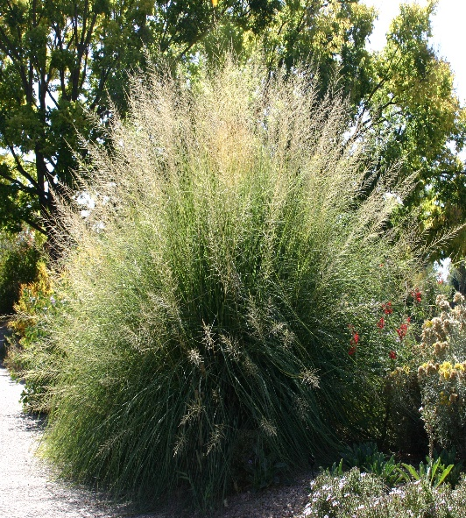

**Height: 5-7 ft. Width: 3-5 ft.**

Extravagant fountains of luxuriant foliage create a focal point in the Xeriscape™ garden. A wonderful southwestern native alternative to Pampas grass.

**Culture:** Clay, loam or sandy soil

**Hardiness:** USDA zones 5-8



WIND. HAIL. SNOW. SUN

**BRING IT ON**

www.plantselect.org

